**MANAV RACHNA INTERNATIONAL**

**INSTITUTE OF REASEARCH & STUDIES**

**FACULTY OF ENGINEERING AND TECHNOLOGY**



**PRACTICAL FILE**

**FOR**

**VIIth SEMESTER (ACADEMIC YEAR 2021-2022)**

**SUBJECT NAME: ITNS Lab**

**SUBJECT CODE: BCS-DS-774**

|  |  |
| --- | --- |
| **SUBMITTED BY:-** | **SUBMITTED TO:-** |
| **STUDENT NAME: Swarna Krishnan Kuchibhitla** | **FACULTY NAME: Dr. Urvashi Chugh** |
| **ROLL NO.: 1/18/FET/BCS/202** | **DEPARTMENT: FET** |
|  |  |
|  |

**INDEX**

|  |  |  |  |
| --- | --- | --- | --- |
| **PRACTICAL NO.** | **AIM OF PRACTICAL** | **DATE ON WHICH CONDUCTED** | **TEACHER’S SIGNATURE** |
|  | To Install Kali Linux | 27/07/21 |  |
|  | To Install Windows 7 | 27/07/21 |  |
|  | To Implement all commands on NMAP for Network Scanning | 17/08/21 |  |
|  | To Implement ARP Spoofing | 3/08/21 |  |
|  | To Implement Nessus basic Scan | 31/08/21 |  |
|  | To Perform DNS Spoofing Attack | 10/09/21 |  |
|  | To use Metasploit framework to exploit system | 14/09/21 |  |
|  | Implementation of Foot Printing Lab | 21/09/21 |  |
|  | Implementation of Cryptography Labs | 28/09/21 |  |
|  | Implementation of File System Security | 5/10/21 |  |
|  | Implementation of Network Security Tools and Technologies Lab | 26/10/21 |  |

**EXPERIMENT -01**

**AIM**- **Installation of virtual box and windows 7**

VirtualBox is a cross-platform virtualization application. What does that mean? For one thing, it installs on your existing Intel or AMD-based computers, whether they are running Windows, Mac, Linux or Solaris operating systems. Secondly, it extends the capabilities of your existing computer so that it can run multiple operating systems (inside multiple virtual machines) at the same time. So, for example, you can run Windows and Linux on your Mac, run Windows Server 2008 on your Linux server, run Linux on your Windows PC, and so on, all alongside your existing applications. You can install and run as many virtual machines as you like -- the only practical limits are disk space and memory.

VirtualBox is deceptively simple yet also very powerful. It can run everywhere from small embedded systems or desktop class machines all the way up to datacentre deployments and even Cloud environments.

The following screenshot shows you how VirtualBox, installed on a Mac computer, is running Windows 8 in a virtual machine window:

**STEPS FOR INSTALLATION OF VIRTUAL BOX: -**

**PART-1: CREATE THE VIRTUAL MACHINE**

**STEP-1: Download VirtualBox.** VirtualBox from Oracle is available for free from the developer's website. Make sure that you download the correct version for your operating system.

* There are multiple choices for Linux or Windows versions. Choose the package that matches your Linux or Windows distribution or use the "All distributions" option if your Linux distribution is not listed.

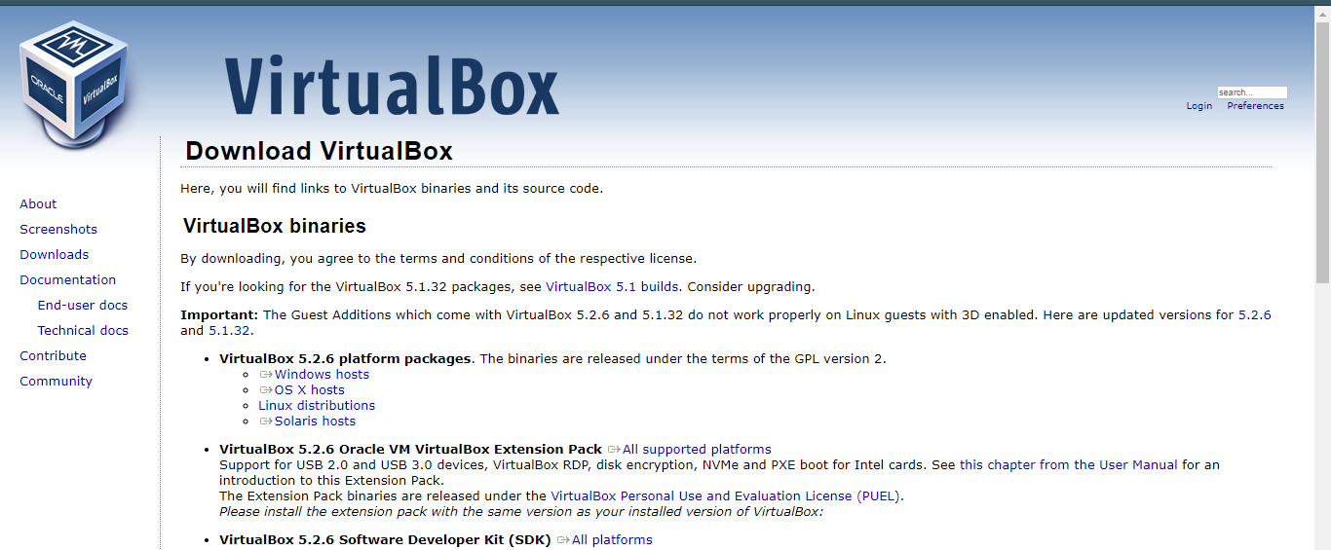

**STEP-2: Install the VirtualBox program.** If you are using Windows, double-click the setup file and follow the prompts to install. If you are using a Mac, open the DMG file that you downloaded and drag the VirtualBox file to your Applications folder.

* During the Windows installation, keep all the options set to their default.

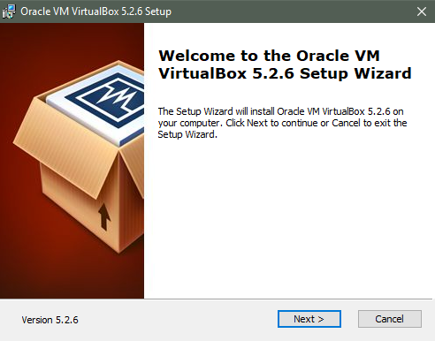

**STEP-3: Start the program.** VirtualBox allows you to manage your various virtual machines, and easily create new ones. You can run VirtualBox directly from the installation program, or you can start it from the desktop icon.

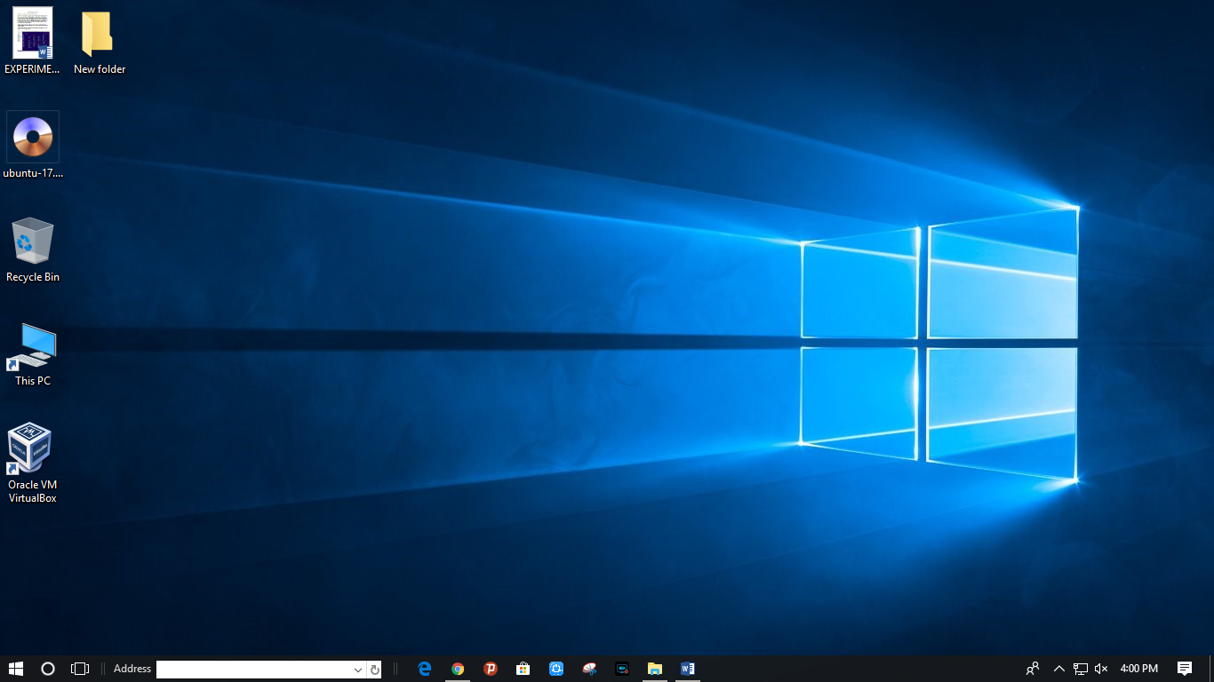

**STEP-4: Gather your installation disc(s).** When creating a virtual machine, you will need to install the operating system just like you would on a regular computer. This means that you will need the installation discs for the operating system you want to install on the virtual machine.

* If you download the ISO file for the installation disc, you can burn it to a blank DVD, or install it directly from the ISO file.

**PART-2: Windows installation in Virtual Box**

* **To Install Windows 7 inside of VMware Workstation**
* Download and install VM ware
* Insert the Windows 7 install DVD into your drive
* Run VMware Workstation 7.0 from the Start menu
* Click **New Virtual Machine**  
   [[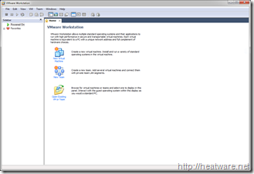](http://heatware.net/wp-content/uploads/2009/11/vmware_windows_7_14.png)](http://heatware.net/wp-content/uploads/2009/11/vmware_windows_7_14.png)
* Choose **Typical** and click **Next**

[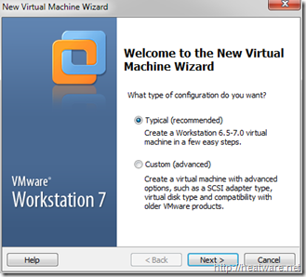](http://heatware.net/wp-content/uploads/2009/11/vmware_windows_7_2.png)

* Choose the option **Installer Disc** and ensure that the optical drive that has the Windows 7 installation DVD is selected.  
  Note: If you have Windows 7 as an ISO image, choose the option labelled: Installed disc image file (iso)

[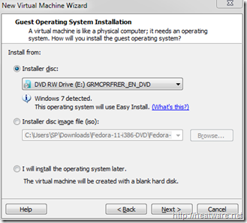](http://heatware.net/wp-content/uploads/2009/11/vmware_windows_7_3.png)

* A convenient new feature is the ability to specify your Windows 7 product key prior to starting the installation to allow for a fully-unattended install. No more coming back to your computer an hour later after you think the installation finished only to find it stuck on a screen asking for a serial number!  
  Go ahead and enter your **Windows product key**and **Full name**. The password is optional. Click **Next**.

[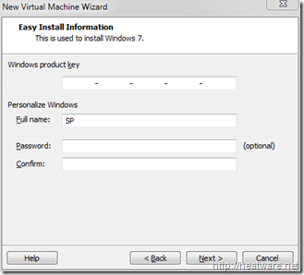](http://heatware.net/wp-content/uploads/2009/11/vmware_windows_7_4.png)

* Now it is time to name the virtual machine and choose the location. We will keep the default location and name the VM **Windows 7 Pro**

[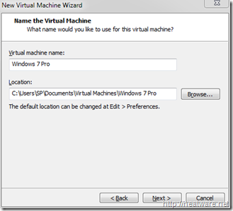](http://heatware.net/wp-content/uploads/2009/11/vmware_windows_7_5.png)

* VMware needs to know how hard drive space to allocate to the Windows 7 disk. Lets stick with the 40.0 GB default and click **Next**.

[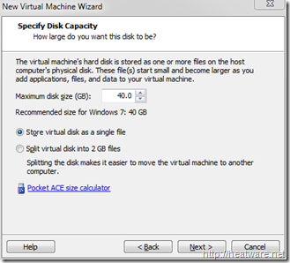](http://heatware.net/wp-content/uploads/2009/11/vmware_windows_7_6.png)

Now you will be presented with a summary screen that shows all the VM configuration parameters. Don’t worry, you can change most of these at any time! Click **Finish** to begin the installation!

[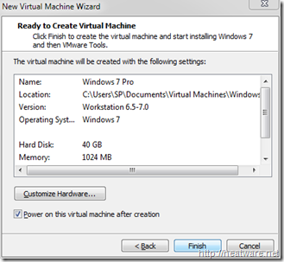](http://heatware.net/wp-content/uploads/2009/11/vmware_windows_7_7.png)

* The virtual machine will now boot up and load the Windows 7 installer from the DVD. If you need to step away from the computer, go ahead, no more user-intervention is needed.

[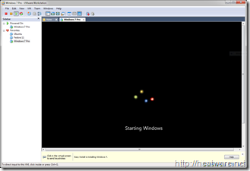](http://heatware.net/wp-content/uploads/2009/11/vmware_windows_7_8.png)

* The installer will now copy files… This will take a while…

[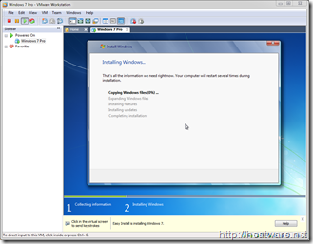](http://heatware.net/wp-content/uploads/2009/11/vmware_windows_7_9.png)

* Your system will reboot…

[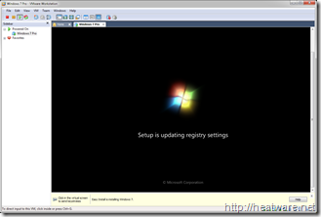](http://heatware.net/wp-content/uploads/2009/11/vmware_windows_7_10.png)

* And continue installing…

[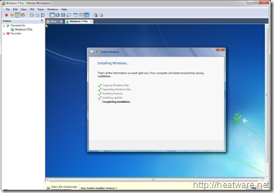](http://heatware.net/wp-content/uploads/2009/11/vmware_windows_7_11.png)

* And about 30 minutes later, its all done!

[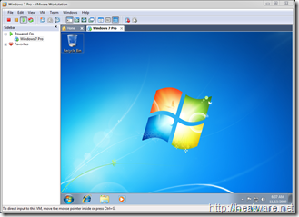](http://heatware.net/wp-content/uploads/2009/11/vmware_windows_7_12.png)

* Now is a great time to save the state of your VM by taking a snapshot. This way, if you shut down VMware, you don’t have to start all over again! Right click on *Windows 7 Pro* in the left panel and choose **Take Snapshot**

[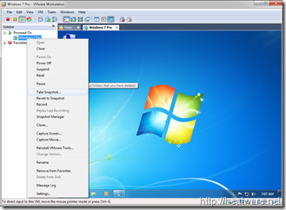](http://heatware.net/wp-content/uploads/2009/11/vmware_windows_7_13.png)

**EXPERIMENT -02**

**AIM- Installation of Kali Linux**

Kali is an operating system based on Debian that is used by security experts called penetration testers to test the security of hardened systems. Kali comes with an extensive list of tools that you can use to test how secure your server is, ranging from testing anti-virus software to social engineering attacks and malware. This operating system is for intermediate to advance users and while it does come with the Gnome Desktop Environment, most of its features will require you to be proficient in the use of the terminal. Don’t let that scare you, the terminal is often easier and quicker than graphical user interfaces.

**Let’s get started; Install Kali Linux 2021.1:**

**Step 1: Create a USB installer**

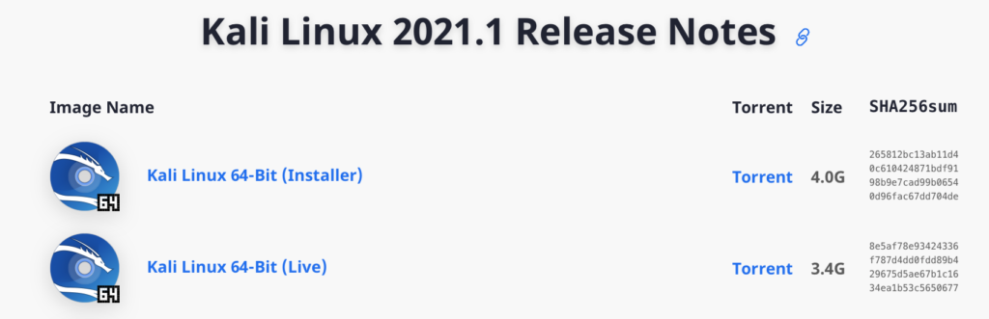

First thing is first, you are going to need to boot into a USB installer to start the installation process. This involves two parts; first, download a copy of Kali Linux 2021.1 from their [Official Website](https://www.kali.org/downloads/). There are two versions of the ISO, one is an installer, the other is for the live version of kali. Choose the one labelled installer.

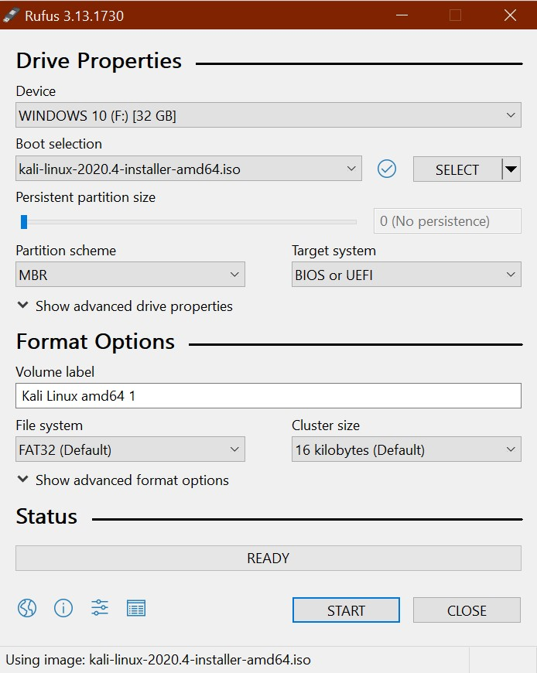

Then download [Rufus](https://rufus.ie/) which is the tool you will need to create your USB installer with a few simple clicks. [Click here](https://github.com/pbatard/rufus/releases/download/v3.13/rufus-3.13.exe) to download version 3.13 of Rufus or go to [Rufus.ie](https://rufus.ie/) and download the latest version.

***Step 2: Boot to the USB drive***

Make sure your recently created USB installer is plugged into the computer you would like to install Kali Linux 2021.1 into then power it on and as it boots continuously tap either the F10 or F12 (depends on your computer) function key on your keyboard to enter the boot menu then choose your USB drive to boot into.

***Step 3: Start the installation***

The Kali USB installer unlike many Linux distro’s does not come with a version of the operating system already installed on the USB drive called “live USB”. If you would like to run Kali as a live USB you will need to create a bootable USB from the live ISO available on the Kali Downloads page.

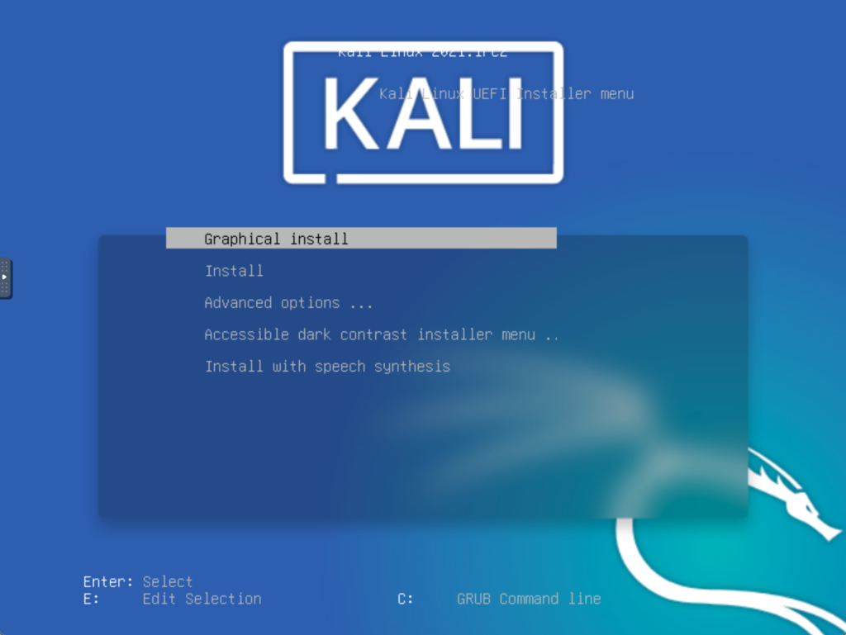

You can choose “Graphical install” to get started; If you run into any problems then select the regular “Install” option.

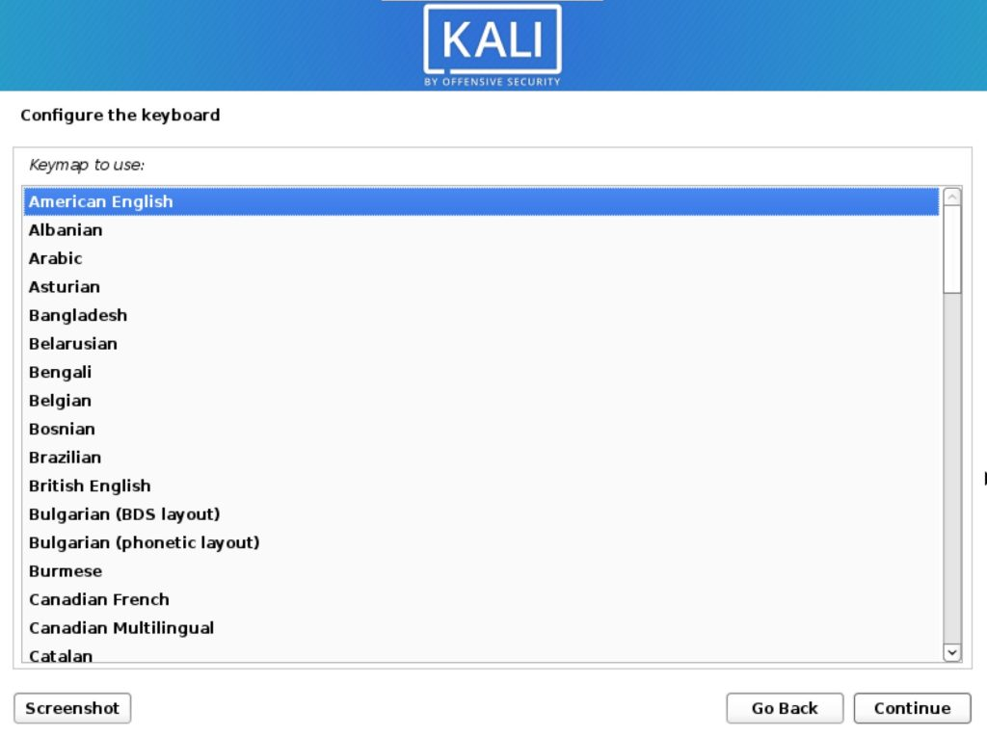

Next, pick your desired language and click continue. Then choose your location before you continue; then choose your keyboard layout and go through any other options you are prompted with.

***Step 4: Choose some options***

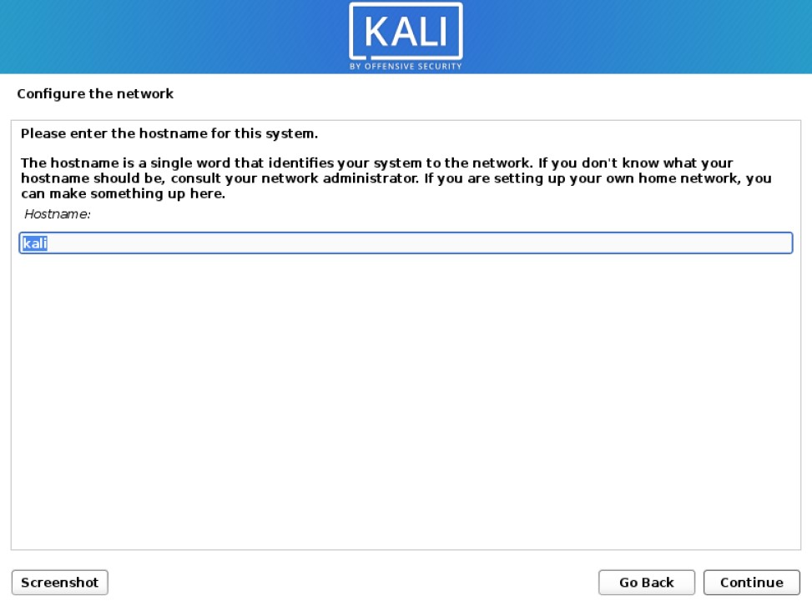

Enter your desired hostname then move on to the next option; a hostname is what identified your computer to the network you connect to.

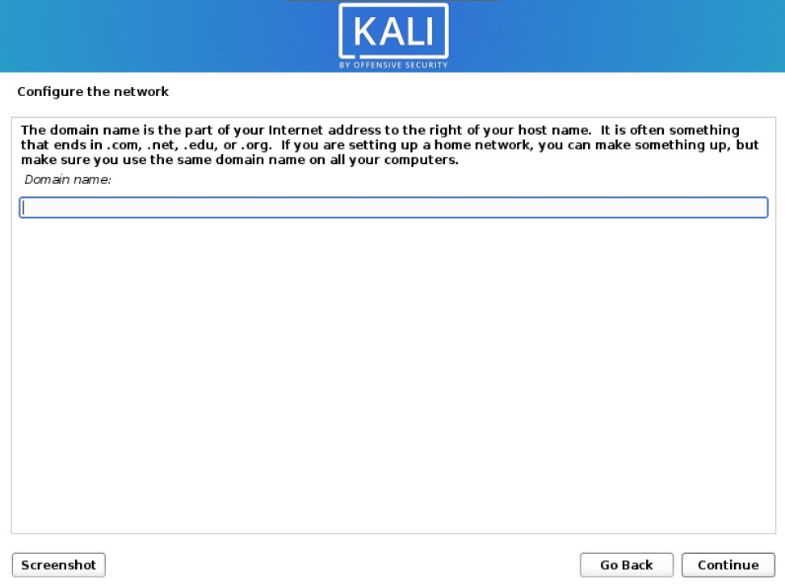

Enter a domain name here if you would like to or leave it blank if you do not have one;

Since Kali 2020.1 you are required to create a Non-Root user which will serve as the default user instead of the traditional root from versions of Kali prior to 2020.1. After installation, if you prefer to use Root you can activate it and set a password if that is the direction you would like to go.

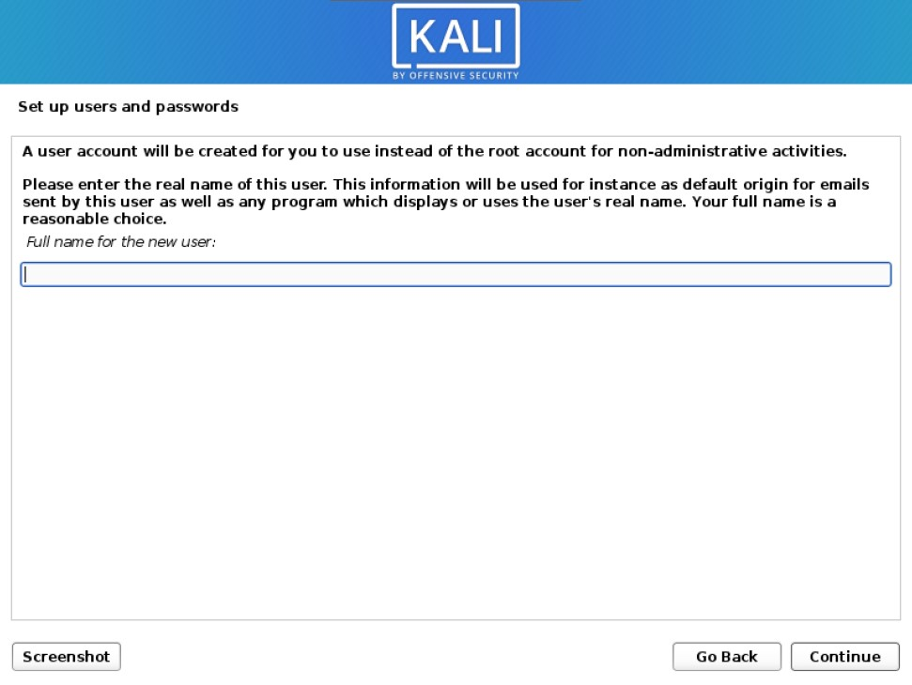

For now enter your desired name, followed by a username, and finally a password.

***Step 5: Partition the Drive***

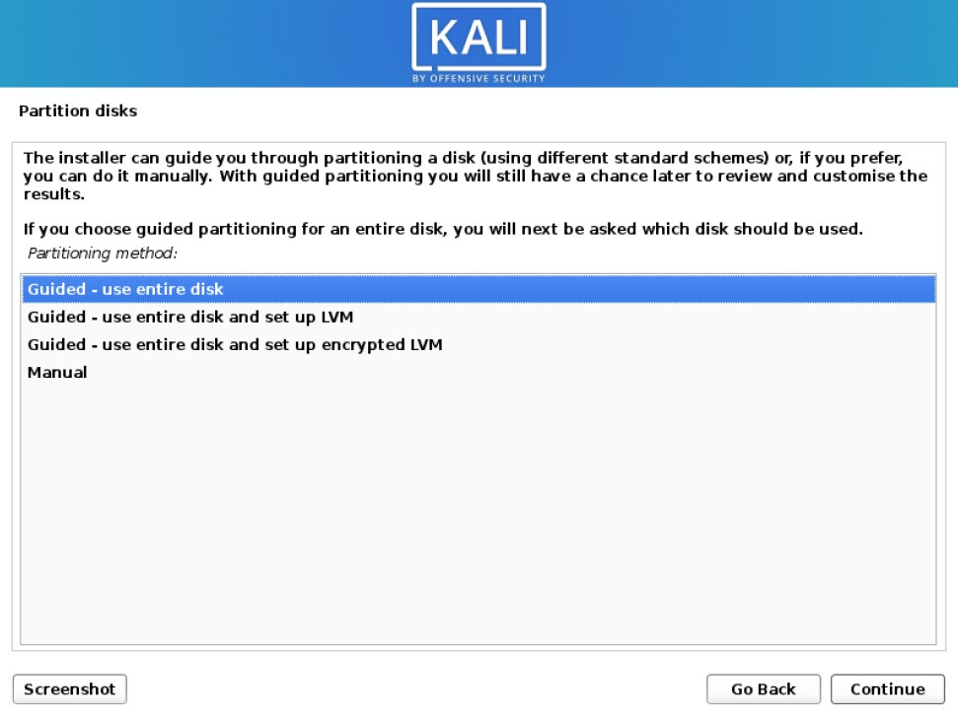

Here you may choose partition options and you may choose to enable and configure whole disk encryption or LVM (logical volume management) or customize your partitions to your own liking. For most people, the default options are probably going to be just fine. Click continue then follow the onscreen instructions to confirm the partition you have chosen.

***Step 6: Finalize the Installation***

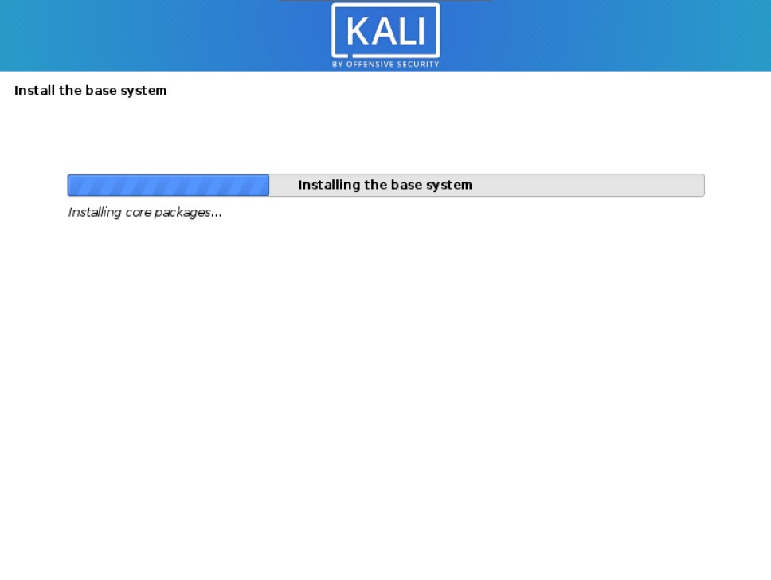

Your installation has begun now, note that this will take several minutes depending on how fast your system is.

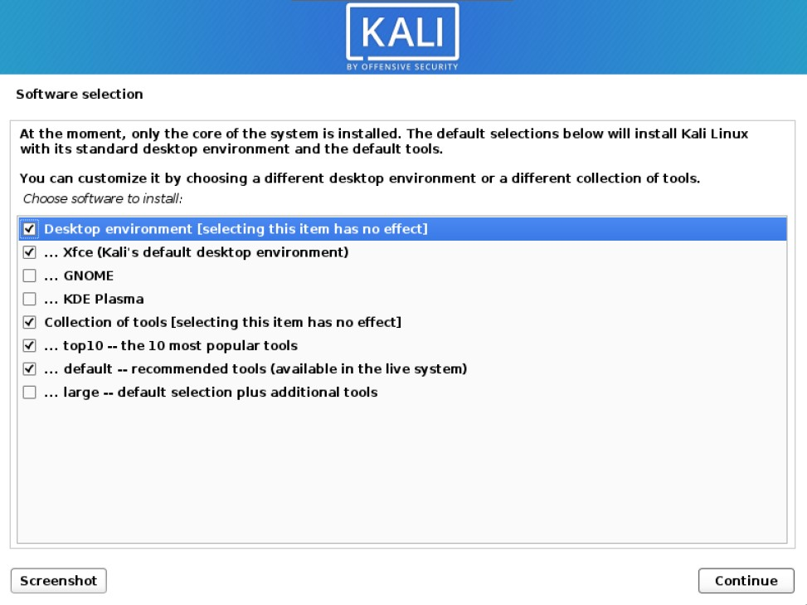

You will be prompted with some software options, which include desktop environments, and what tools you would like to install. Do note that you can install these tools later should you change your mind. Or find that you require more tools than you originally had chosen at installation. XFCE is Kali’s default desktop environment, but you can choose GNOME or KDE plasma if you prefer.

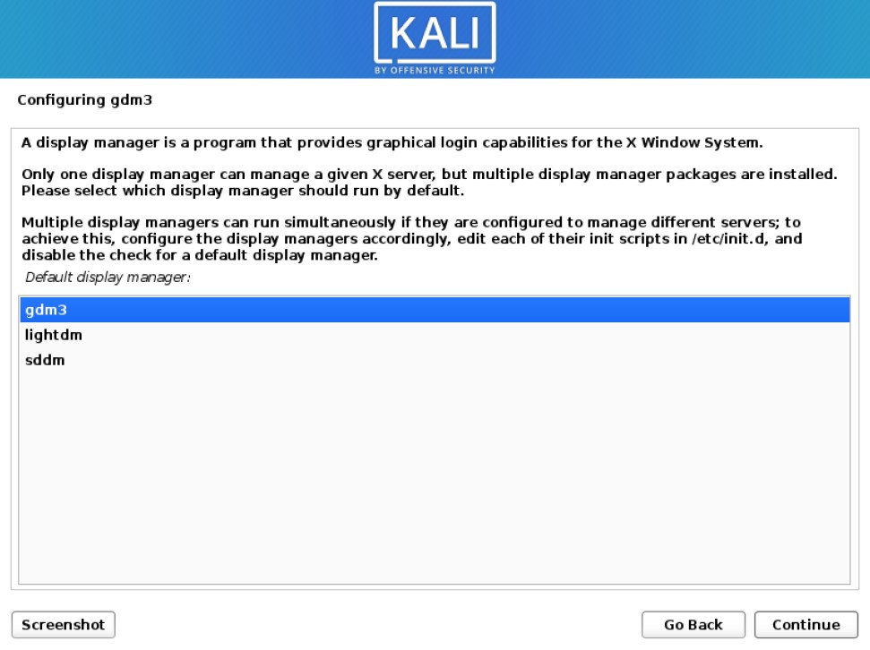

Shortly after you may be prompted to choose a display manager. This may occur if you have chosen to install more than one desktop environment. Select whichever display manager you like best and click continue.

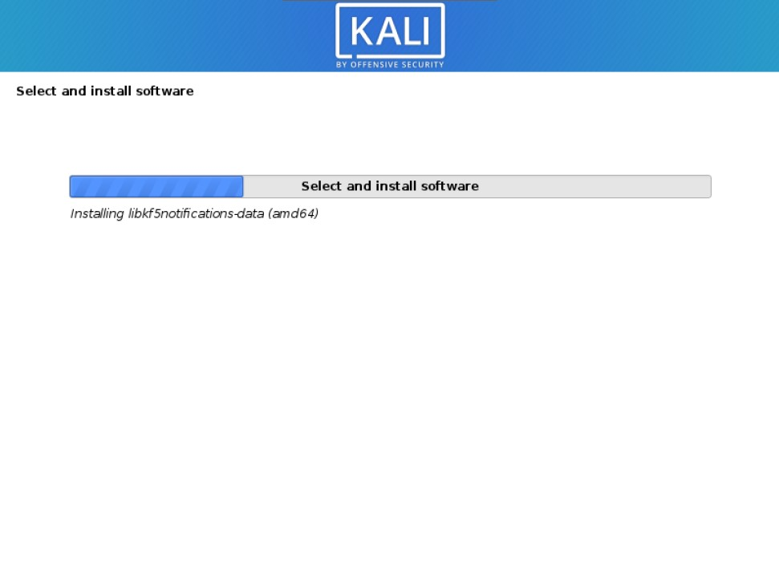

The installation will then continue; this should take a few more minutes depending on how fast your system is. When your installation is complete you will be prompted to restart your system. Click continue and in no time you will be greeted with a login prompt.

#### **Welcome to your Desktop;**

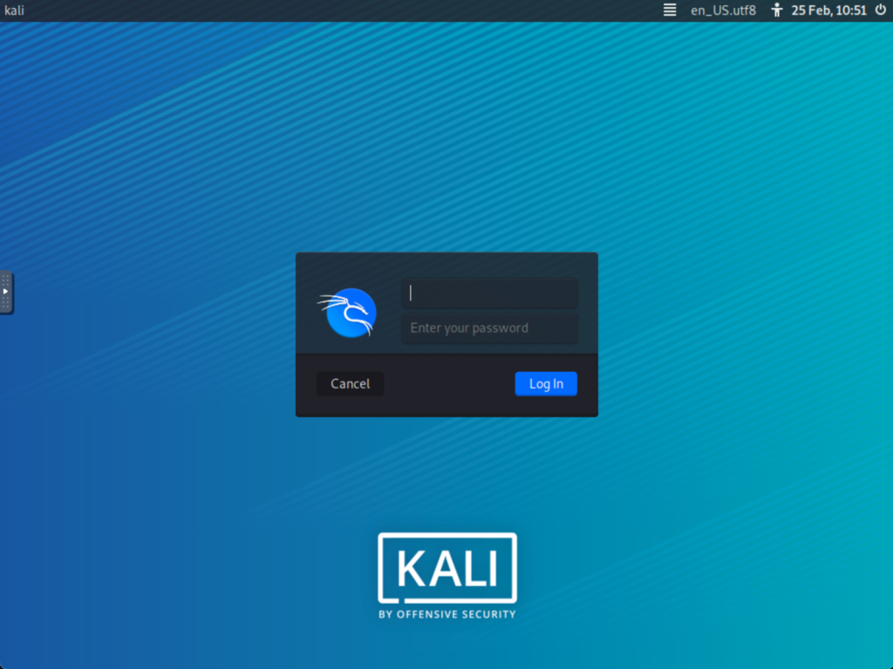

Your installation does not immediately boot up, it does require that you first key in a username and password. Use the username and password you set earlier during setup;

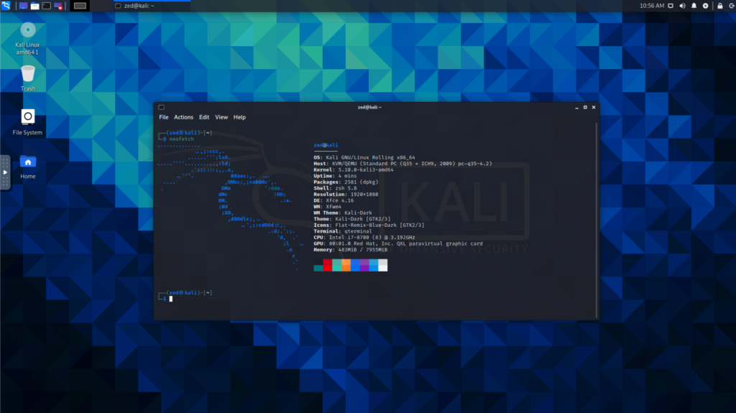

Now that you have installed Kali Linux you can log in. Next, you will be greeted by the desktop environment that you have chosen during installation.

**EXPERIMENT -03**

**Aim: Arp spoofing attack & Mitm Attack using Bettercap Tool**

Theory: Address Resolution Protocol (ARP) is a stateless protocol used for resolving IP addresses to machine MAC addresses. All network devices that need to communicate on the network broadcast ARP queries in the system to find out other machines’ MAC addresses. ARP Poisoning is also known as **ARP Spoofing**.

Here is how ARP works −

* When one machine needs to communicate with another, it looks up its ARP table.
* If the MAC address is not found in the table, the **ARP_request** is broadcasted over the network.
* All machines on the network will compare this IP address to MAC address.
* If one of the machines in the network identifies this address, then it will respond to the **ARP_request** with its IP and MAC address.
* The requesting computer will store the address pair in its ARP table and communication will take place.

**What is ARP Spoofing?**

ARP packets can be forged to send data to the attacker’s machine.

* ARP spoofing constructs a large number of forged ARP request and reply packets to overload the switch.
* The switch is set in **forwarding mode** and after the **ARP table** is flooded with spoofed ARP responses, the attackers can sniff all network packets.

Attackers flood a target computer ARP cache with forged entries, which is also known as **poisoning**. ARP poisoning uses Man-in-the-Middle access to poison the network.

**What is MITM?**

The Man-in-the-Middle attack (abbreviated MITM, MitM, MIM, MiM, MITMA) implies an active attack where the adversary impersonates the user by creating a connection between the victims and sends messages between them. In this case, the victims think that they are communicating with each other, but in reality, the malicious actor controls the communication.

A third person exists to control and monitor the traffic of communication between two parties. Some protocols such as **SSL** serve to prevent this type of attack.

**Practical:**

**Step1**: Check Attacker’s IP(Kali Linux) & MAC Address (ether)

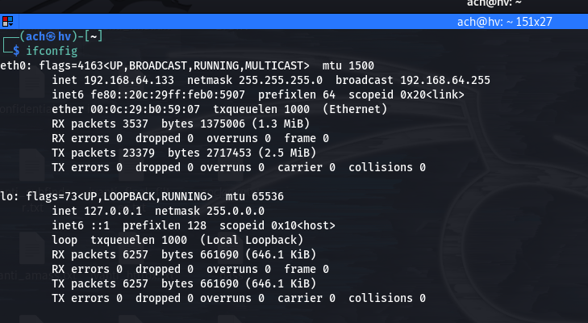

**Step2**: Check Victim’s IP (Windows 7)

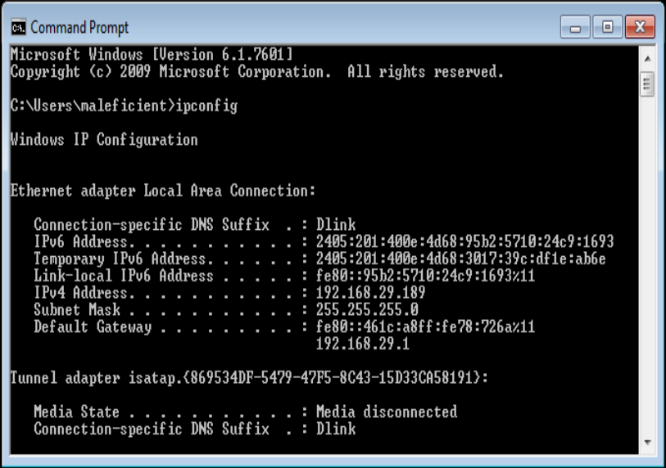

Step3: From attacker’s machine, run the tool (sudo bettercap -iface eth0). This command will execute the code of the bettercap tool and you just have to select your interface.

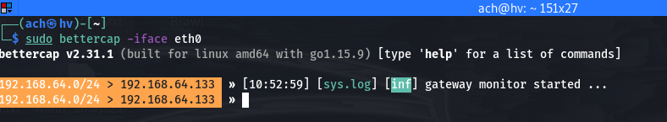

**Step4**: Now by the following command we are gathering information of the devices that are connected in our network.

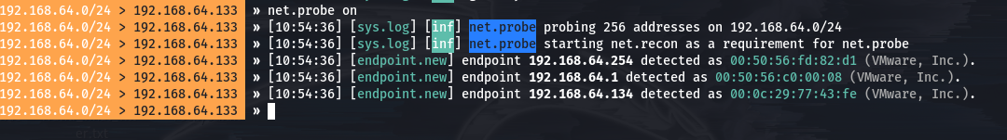

**Step5**: The following command will show the connected devices in that network in a tabular view. From here you can select the victim.

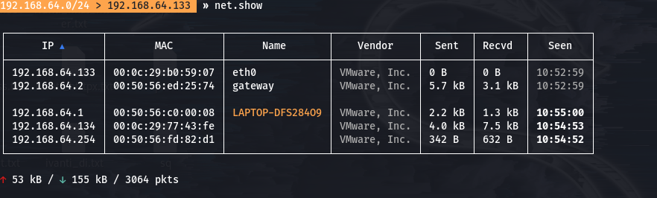

**Step6**: We have to turn the ful duplex mode on, so that we can intercept the traffic of our router and the victim at the same time. Also we select our target (192.168.64.134) or the list of targets to whom we want to attack. Finally turn on the arp spoofing to execute the attack.

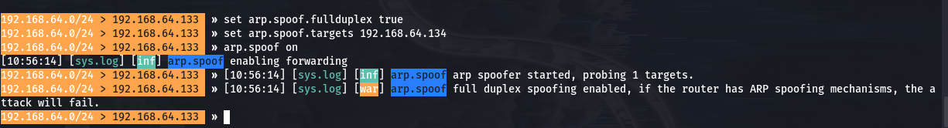

**Step7**: If we go and check the victim’s PC, we found that the mac address of the gateway/router(192.168.64.2) and the attacker(192.168.64.133) are same. It means arp spoofing successfully executed.

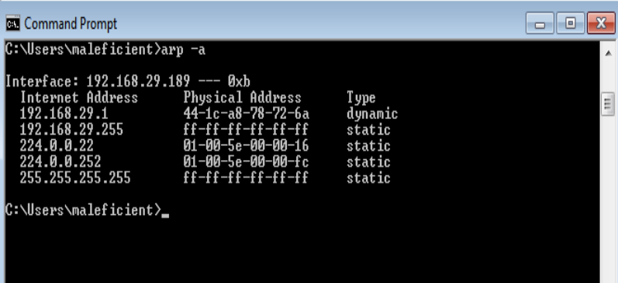

**Step8**: Now in this final step we only have to turn on the sniffer which will sniff packets of the victim and acts as a mitm (man in the middle ) attack.



**Step9**: Now if the victim enters his credentials in his browser that information also goes to attacker first then to the router.

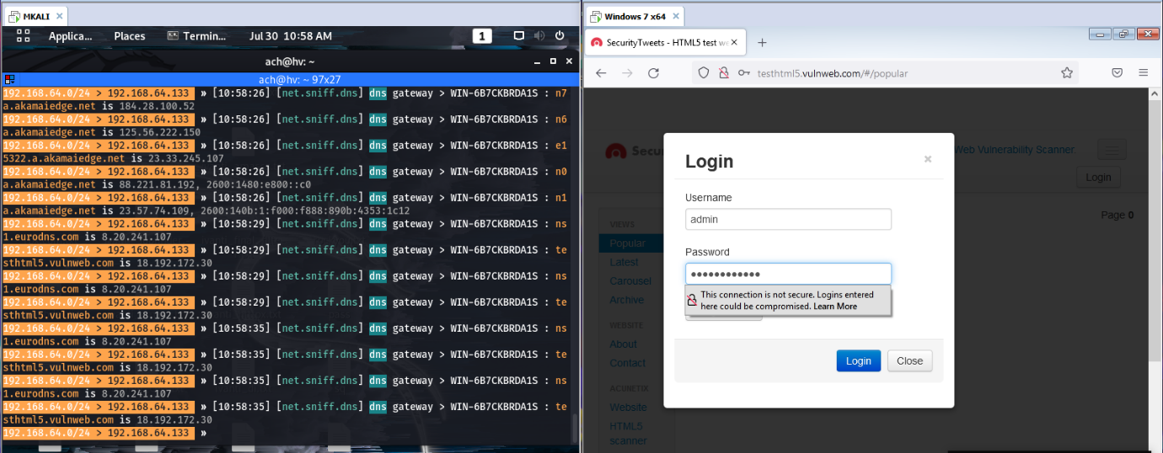

**Step10**: Credentials intercepted as you can see the account and password of the victim in clear text format.

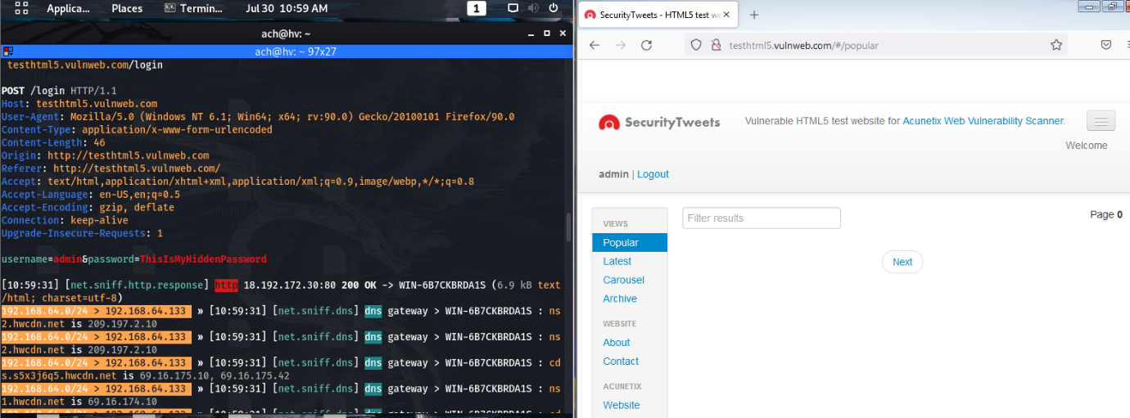

**EXPERIMENT -04**

**Aim: DNS (Domain name System) poisioning attack using Bettercap Tool**

**Theory:** DNS Spoofing is the result of alterations to a DNS server’s records resulting in the malicious redirection of traffic. DNS spoofing can be performed by a direct attack on the DNS server (what we will be talking about here) or through any form of a Man-in-the-Middle attack specifically targeting DNS traffic.

DNS Cache spoofing works explicitly in a way that exploits the way in which DNS communication is structure. When a DNS server attempts to perform a lookup on a domain, it will forward the request along to the root authoritative DNS and iteratively proceed down the chain of DNS servers until it reaches the DNS server authoritative over the domain. Since the local DNS server does not know which server is in charge of which domain, and does not know the full route to each authoritative server, it accepts replies to its queries from anywhere so long as the reply matches the query and is formatted correctly. The attacker can exploit this design by beating the actual Authoritative DNS server in replying to the local DNS server, and if it does so, the local DNS server will use the attacker’s DNS record instead of the actual Authoritative answer. Due to the nature of DNS, the local DNS server has no way of determining which reply is real and which is fake.

**Steps:**

1. Start the windows device and note its IP Address and Subnet Mask using ‘ipconfig command’.



1. Enable Apache Service and open ‘etter.dns’ file using the command, sudo nano /etc/ettercap/etter.dns.

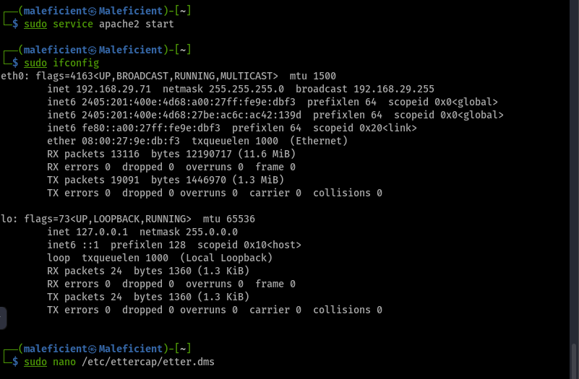

1. Make the changes in dns file.

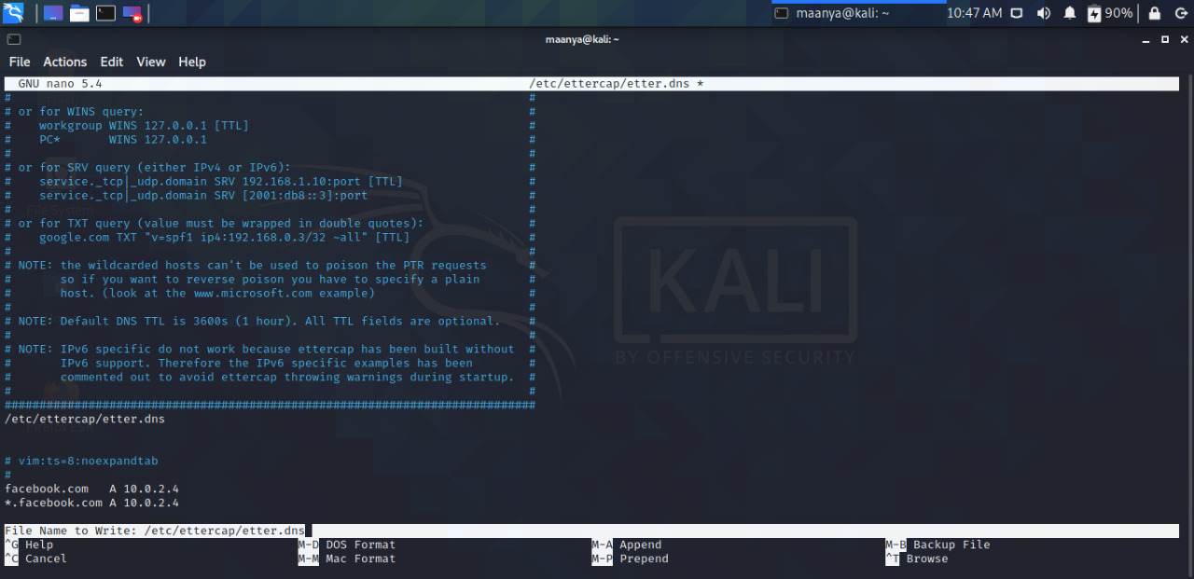

1. Open Ettercap tool and select the target hosts from the scanned hosts list.

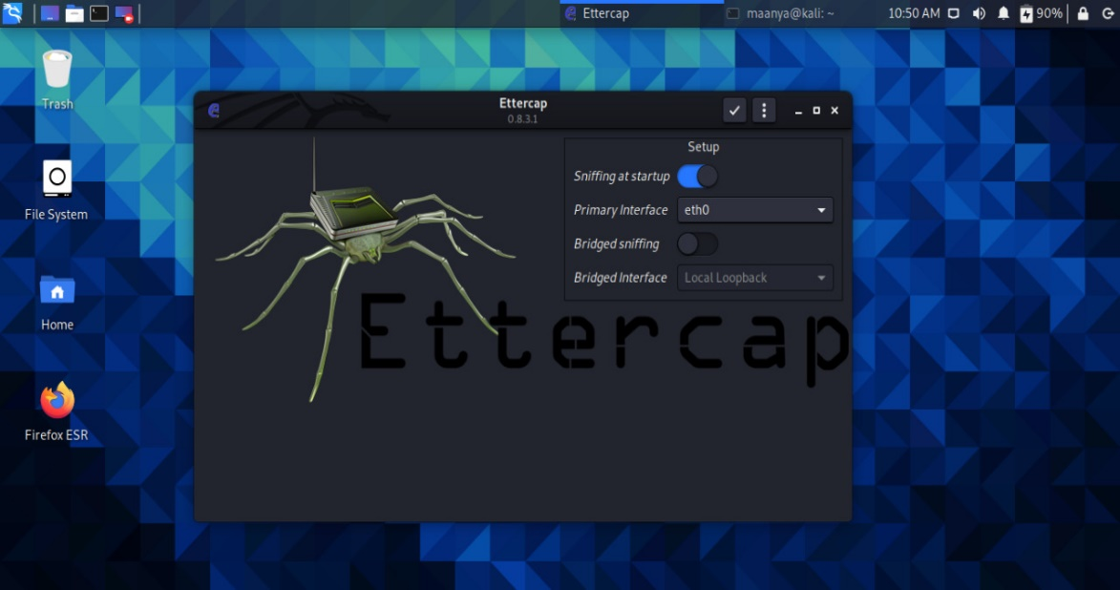

1. Open Plugins and activate the dns spoof plugin by double clicking it.

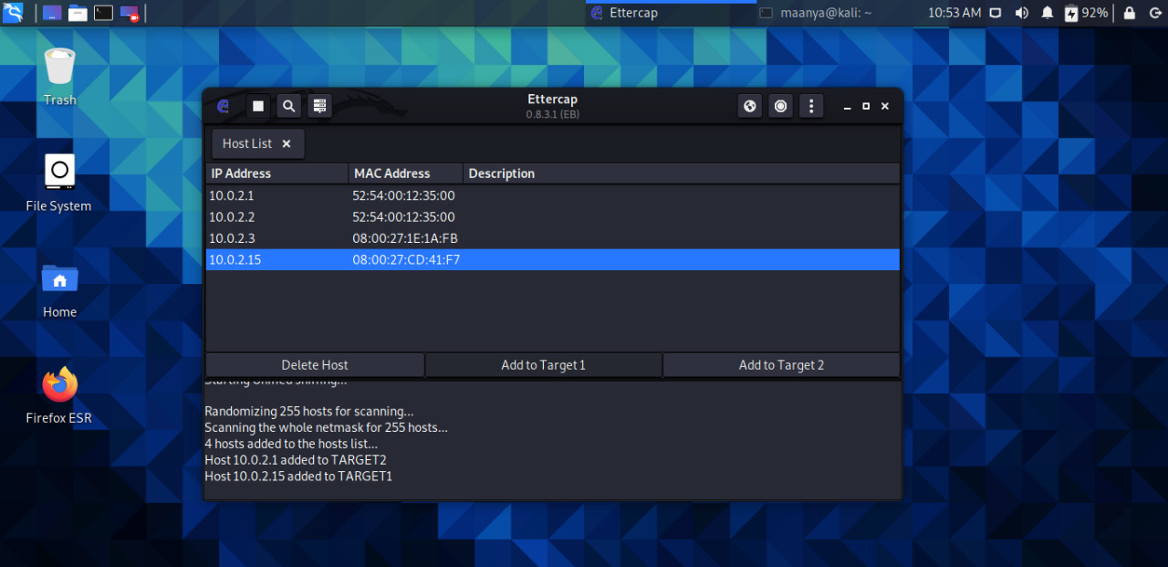

1. Now in the windows machine open the target website, here Facebook.com.

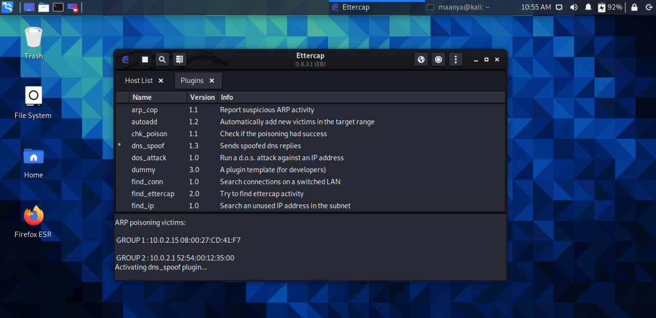

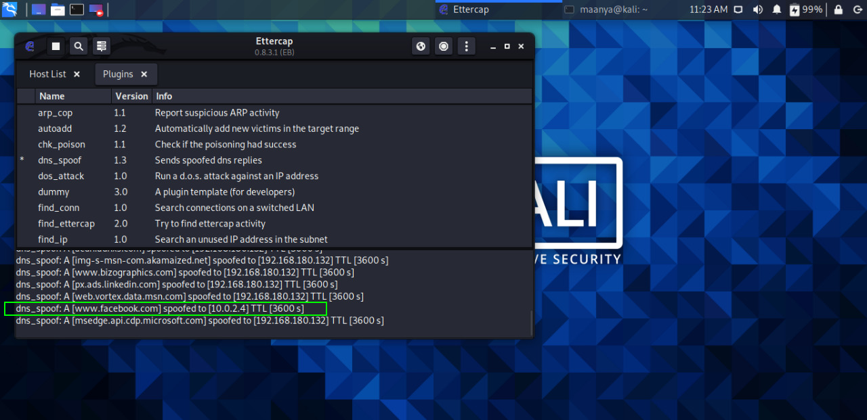

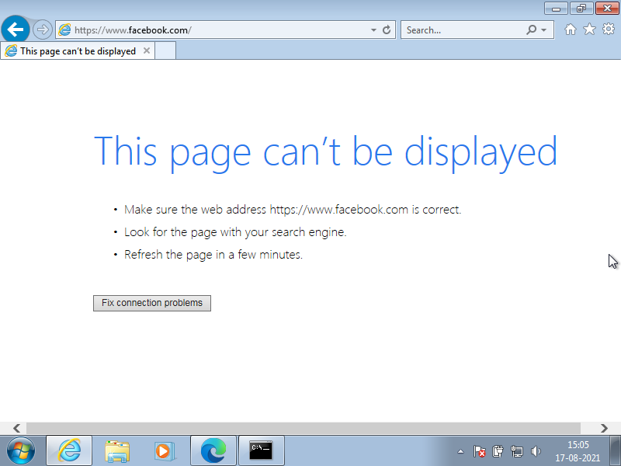

**EXPERIMENT – 05**

**AIM** – **To implement different commands using NMAP**

**Theory**

Nmap (“Network Mapper”) is a free and open source (license) utility for network discovery and security auditing. Many systems and network administrators also find it useful for tasks such as network inventory, managing service upgrade schedules, and monitoring host or service uptime. Nmap uses raw IP packets in novel ways to determine what hosts are available on the network, what services (application name and version) those hosts are offering, what operating systems (and OS versions) they are running, what type of packet filters/firewalls are in use, and dozens of other characteristics. It was designed to rapidly scan large networks, but works fine against single hosts.

Nmap is:

* Flexible: Supports dozens of advanced techniques for mapping out networks filled with IP filters, firewalls, routers, and other obstacles. This includes many port scanning mechanisms (both TCP & UDP), OS detection, version detection, ping sweeps, and more.
* Powerful: Nmap has been used to scan huge networks of literally hundreds of thousands of machines.
* Portable: Most operating systems are supported, including Linux, Microsoft Windows, FreeBSD, OpenBSD, Solaris, IRIX, Mac OS X, HP-UX, NetBSD, Sun OS, Amiga, and more.
* Easy: While Nmap offers a rich set of advanced features for power users, you can start out as simply as “nmap -v -A targethost”. Both traditional command line and graphical (GUI) versions are available to suit your preference. Binaries are available for those who do not wish to compile Nmap from source.

**Steps**:

1. Start the nmap tool in the terminal by writing the command sudo nmap.
2. To Scan a System with Hostname and IP address write the command in the terminal sudo nmap google.com or give the IP address of the desired target.
3. We can use -v command to get more detailed information about the remote machines.
4. Nmap also have the feature to scan multiple hosts at a time. Command used: sudo nmap <multiple IP addresses of different websites>.
5. Nmap can also be used to identify hostnames of the given IP’s by using the command sudo nmap -sL <Random IP Adress>.
6. Nmap also have a command -A which indicates Aggressive it will let Us Know The Extra Information’s like OS Detection (-O), version detection, script scanning (-sC), and traceroute (–traceroute) even it provides a lot of valuable information About The Host.
7. Implement all the above mentioned commands in the Kali Linux Terminal.

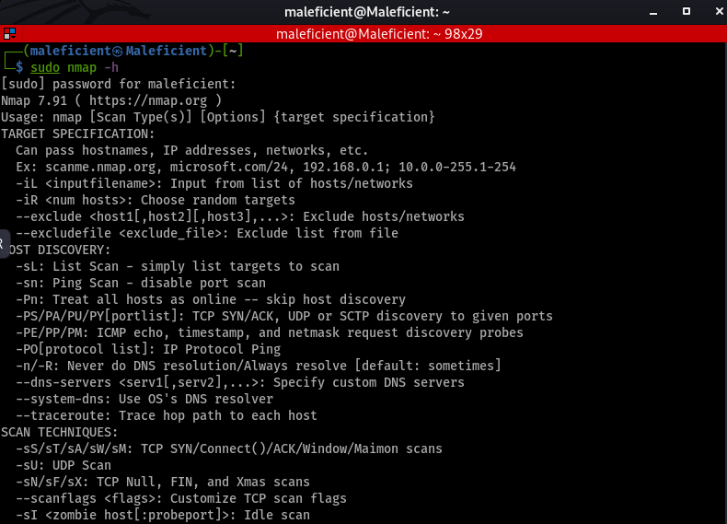

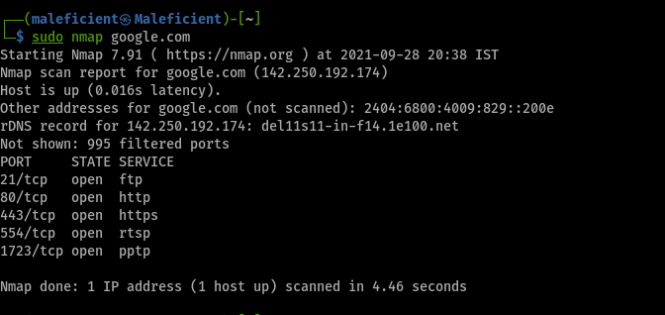

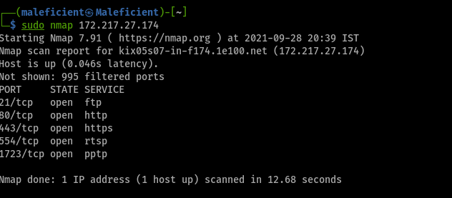

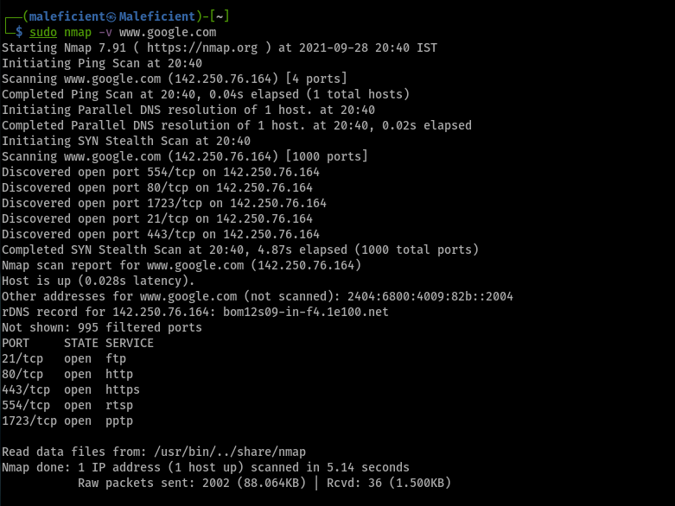

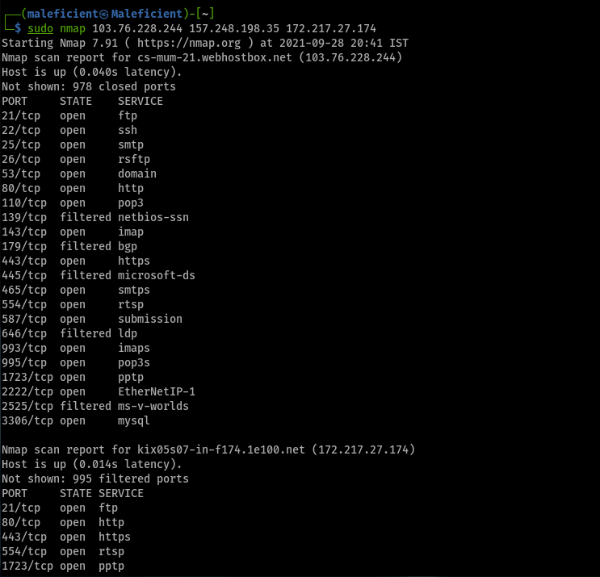

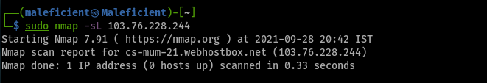

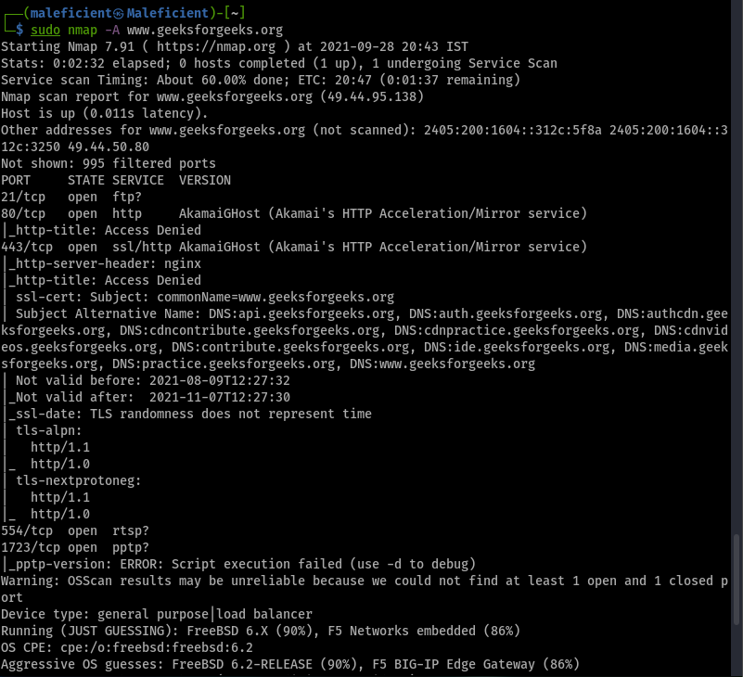

**EXPERIMENT – 06**

**AIM** – To perform vulnerability scanning using Nessus tool.

**Theory**

**What is Nessus?**

Nessus is a remote security scanning tool, which scans a computer and raises an alert if it discovers any vulnerabilities that malicious hackers could use to gain access to any computer you have connected to a network. It does this by running over 1200 checks on a given computer, testing to see if any of these attacks could be used to break into the computer or otherwise harm it.

**Why Nessus?**

If you are familiar with other network vulnerability scanners, you might be wondering what advantages Nessus has over them. Key points include:

* + Unlike other scanners, Nessus does not make assumptions about your server configuration (such as assuming that port 80 must be the only web server) that can cause other scanners to miss real vulnerabilities.
  + Nessus is very extensible, providing a scripting language for you to write tests specific to your system once you become more familiar with the tool. Its also provides a plug-in interface, and many free plug-ins are available from the Nessus plug-in site. These plugs are often specific to detecting a common virus or vulnerability.
  + Up to date information about new vulnerabilities and attacks. The Nessus team updates the list of what vulnerabilities to check for on a daily basis in order to minimize the window between an exploit appearing in the wild, and you being able to detect it with Nessus.
  + Open-source. Nessus is open source, meaning it costs nothing, and you are free to see and modify the source as you wish.
  + Patching Assistance: When Nessus detects a vulnerability, it is also most often able to suggest the best way you can mitigate the vulnerability.

**STEPS**:

1. Create a Scan. To create a scan go to top navigation bar and click Scans or go to upper right corner of the My Scans page, click on the New Scan button.
2. Choose a Scan Template. Click the scan template you want to use. Scan templates simplify the process by determining which settings are configurable and how they can be set.
3. Configure Scan Settings.

**Practical**

**OUTPUT:**

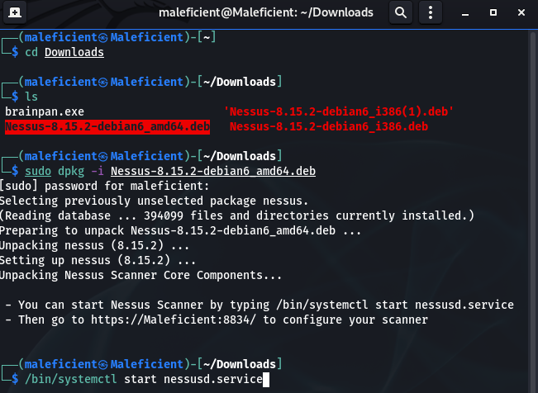

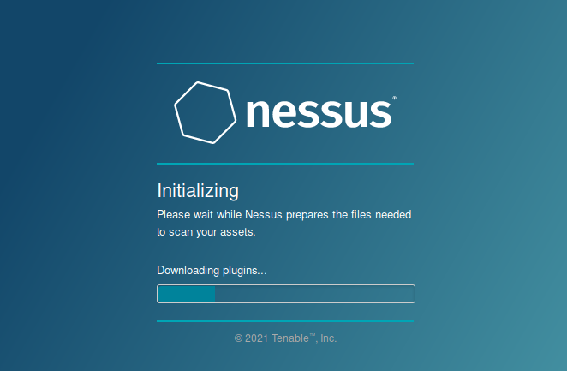

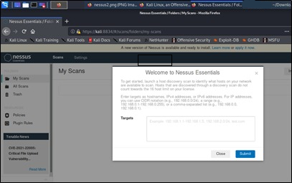

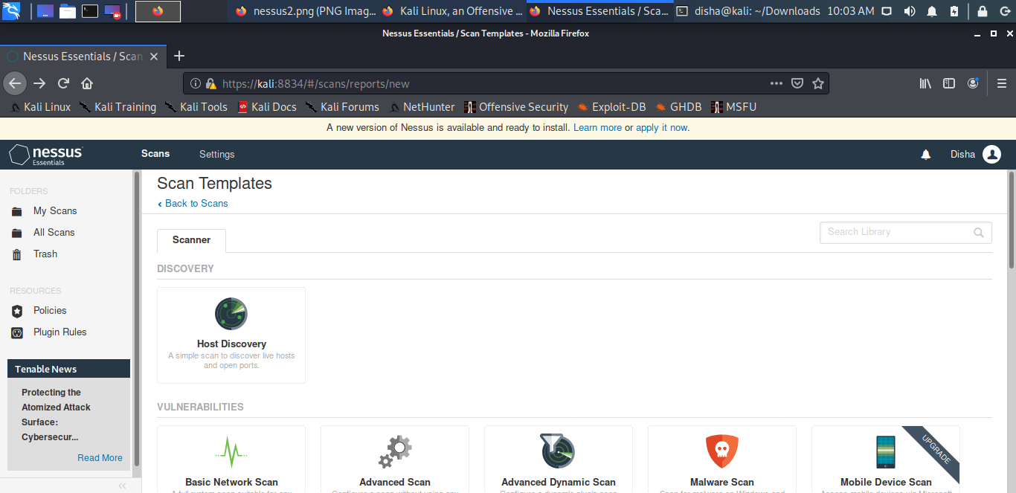

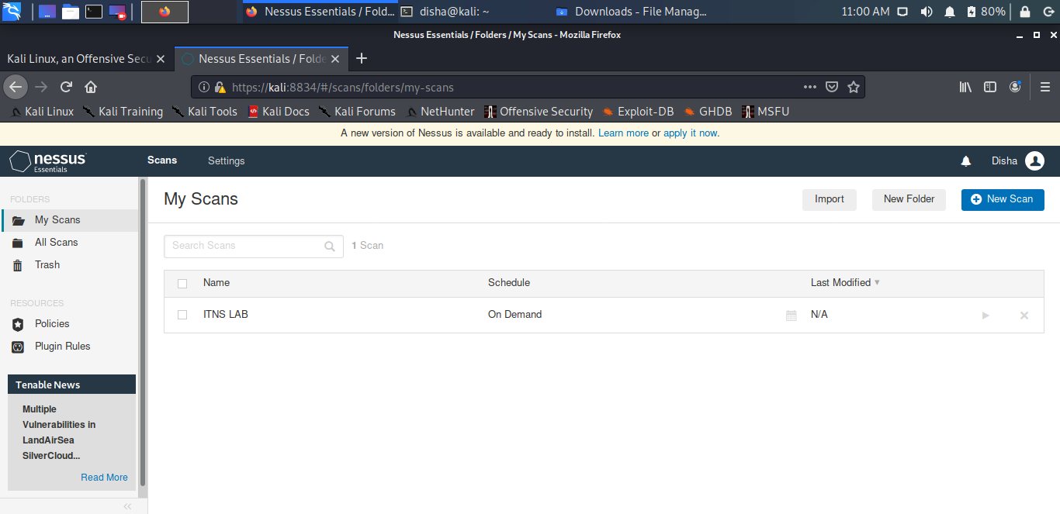

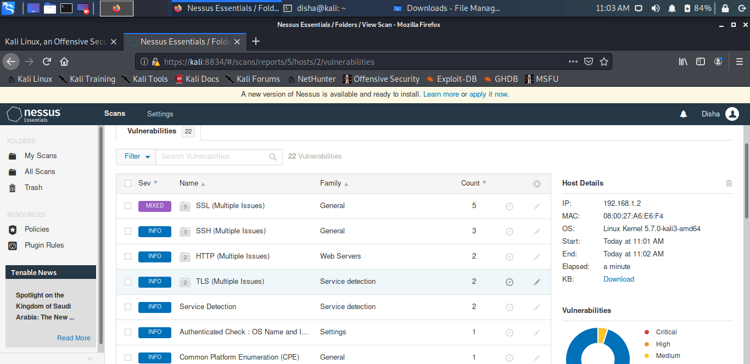

**EXPERIMENT – 07**

**AIM – To implement different commands using Metasploit.**

**Theory**

The Metasploit framework is a very powerful tool which can be used by cybercriminals as well as ethical hackers to probe systematic vulnerabilities on networks and servers. Because it’s an open-source framework, it can be easily customized and used with most operating systems.

Metasploit now includes more than 1677 exploits organized over 25 platforms, including Android, PHP, Python, Java, Cisco, and more. The framework also carries nearly 500 payloads, some of which include:

* Command shell payloads that enable users to run scripts or random commands against a host
* Dynamic payloads that allow testers to generate unique payloads to evade antivirus software
* Meterpreter payloads that allow users to commandeer device monitors using VMC and to take over sessions or upload and download files
* Static payloads that enable port forwarding and communications between networks.

**Steps to perform basic commands**:

1. First of all, open the Metasploit console in Kali. You can do so by following the path: Applications → Exploitation Tools → Metasploit.

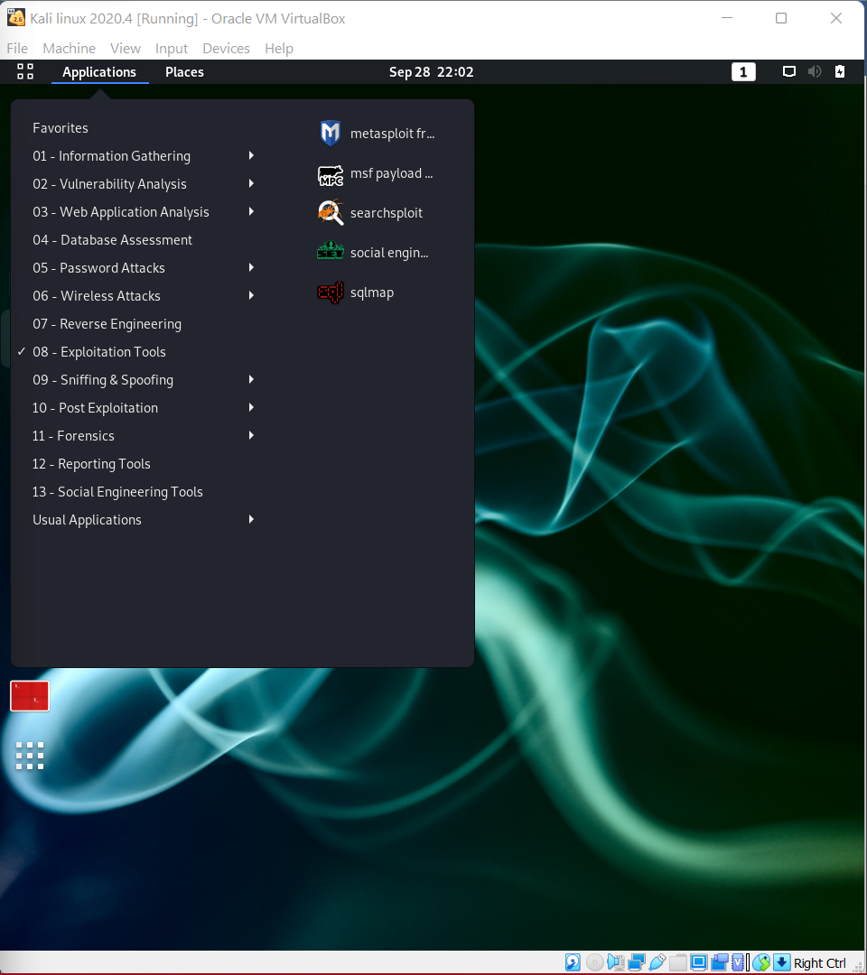

1. Once you open the Metasploit console, you will get to see the following screen. Highlighted in red underline is the version of Metasploit.

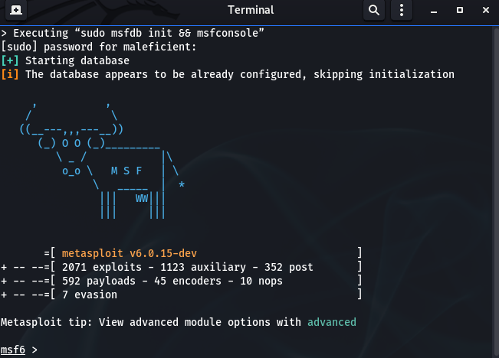

1. Help command

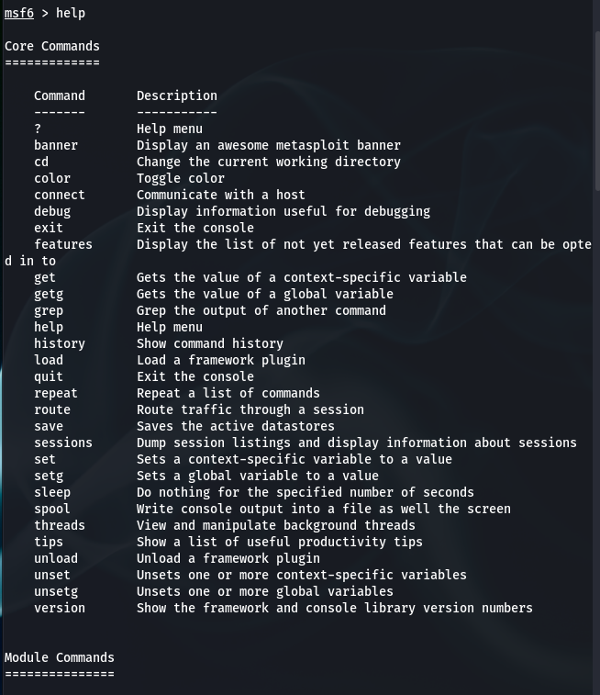

1. Search Command

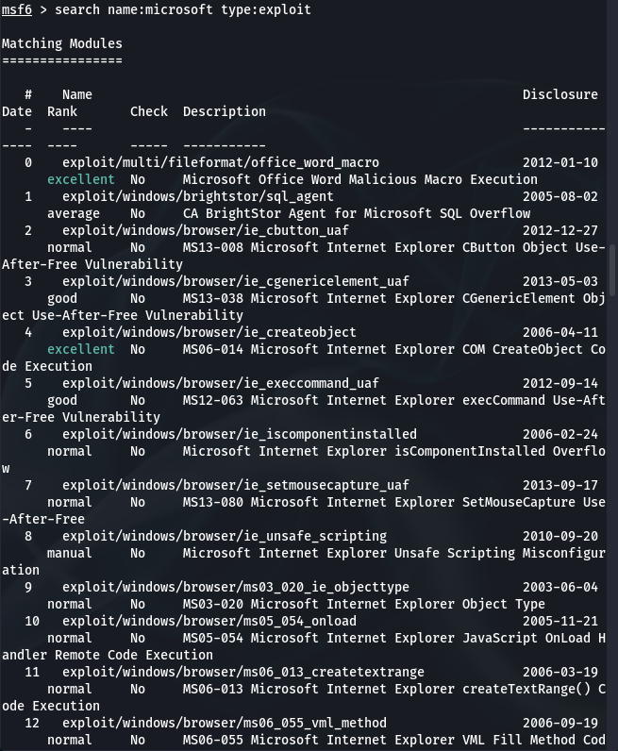

1. Info Command

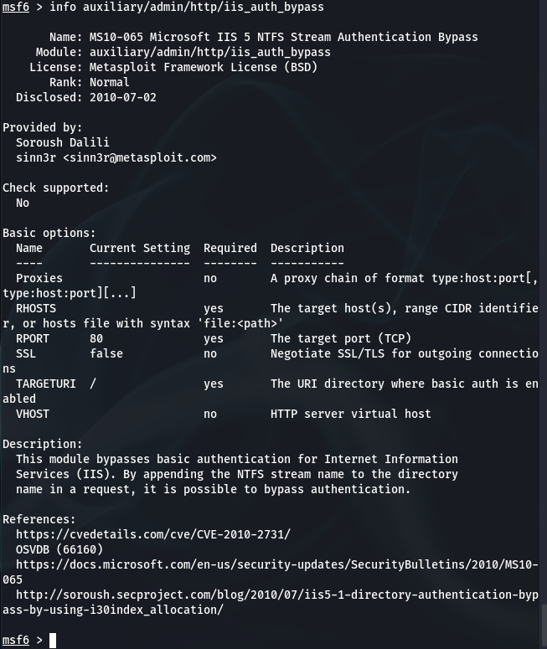

**Steps to Perform Scanning for open ports on the client machine with Metasploit**:

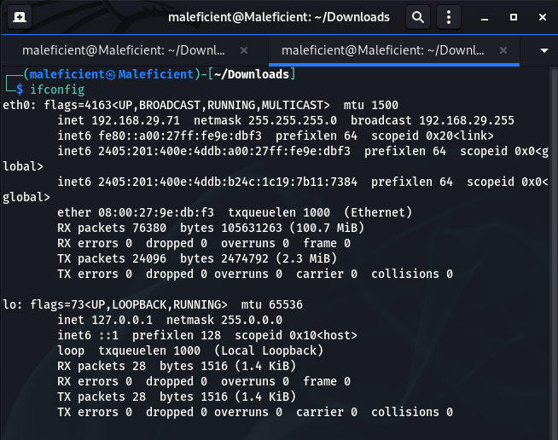

1. We start by launching Metasploit and using the port scanner module.

Msf5 > use auxiliary/scanner/portscan/tcp

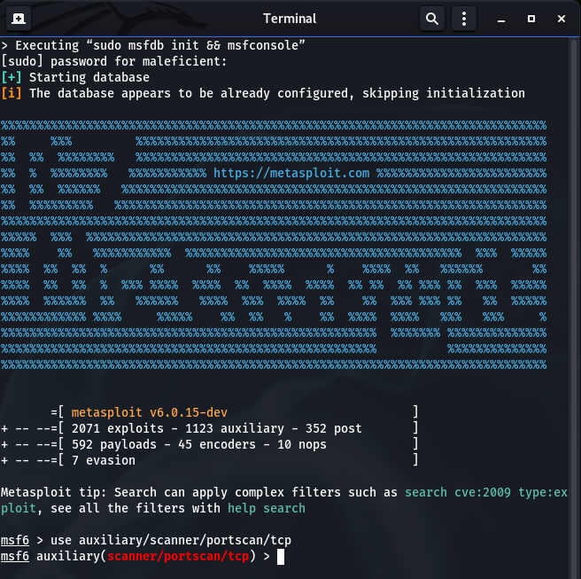

1. We set the options for this module with ‘show option’.

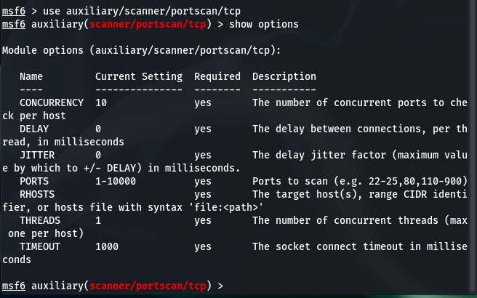

1. We set the RHOSTS with the IP/IP(s) of our client machine and if we want to customize the scan for specific ports we can do that by changing ports.

Msf5> set PORTS 22,25,80, 110, 21

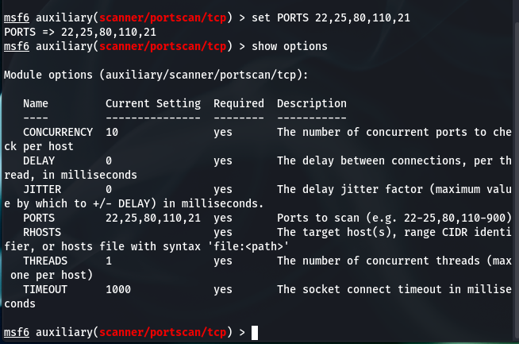

1. After running scan we will have an output displaying the open ports on the target client machine we specified earlier.

**Combining NMAP with Metasploit for a more detailed and in- depth scan on the client machine**:

We can start enumerating the ports to see and fine the running services alongside their version.

Msf5> db_nmap -sV -p 80,22,110, 25 IP address.

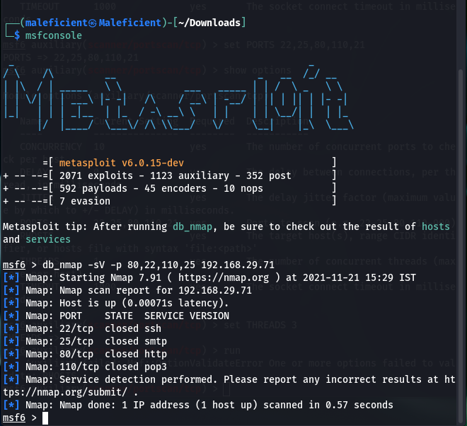

**Scanning for vulnerabilities with Nmap and Metasploit**:

Msf5> dp_nmap -sV -A -p 80,22,110,25 IP address.

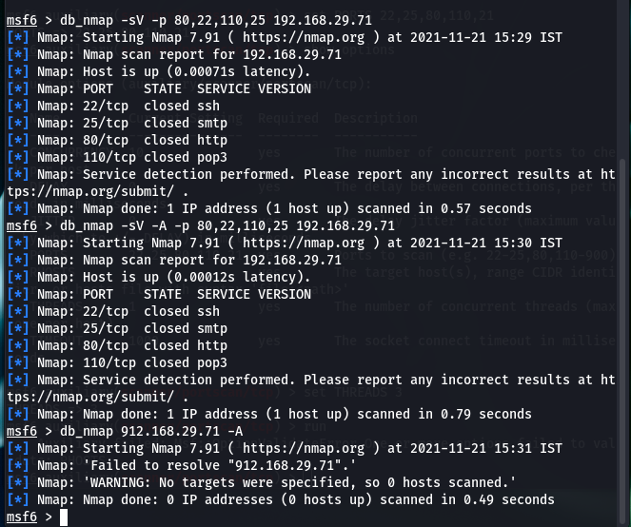

**EXPERIMENT NO – 8**

**AIM:** Implementation of Foot Printing Lab.

**THEORY**:

Footprinting (also known as reconnaissance) is the technique used for gathering information about computer systems and the entities they belong to. To get this information, a hacker might use various tools and technologies. This information is very useful to a hacker who is trying to crack a whole system.

When used in the computer security lexicon, "Footprinting" generally refers to one of the pre-attack phases; tasks performed before doing the actual attack. Some of the tools used for Footprinting are Sam Spade, nslookup, traceroute, Nmap and neotrace.

**USES OF FOOTPRINTING**:

It allows a hacker to gain information about the target system or network. This information can be used to carry out attacks on the system. That is the reason by which it may be named a Pre-Attack, since all the information is reviewed to get a complete and successful resolution of the attack. Footprinting is also used by ethical hackers and penetration testers to find security flaws and vulnerabilities within their own company's network before a malicious hacker does.

**Practical**:

**OUTPUT:**

**WEB TOOL: WHOIS LOOKUP**

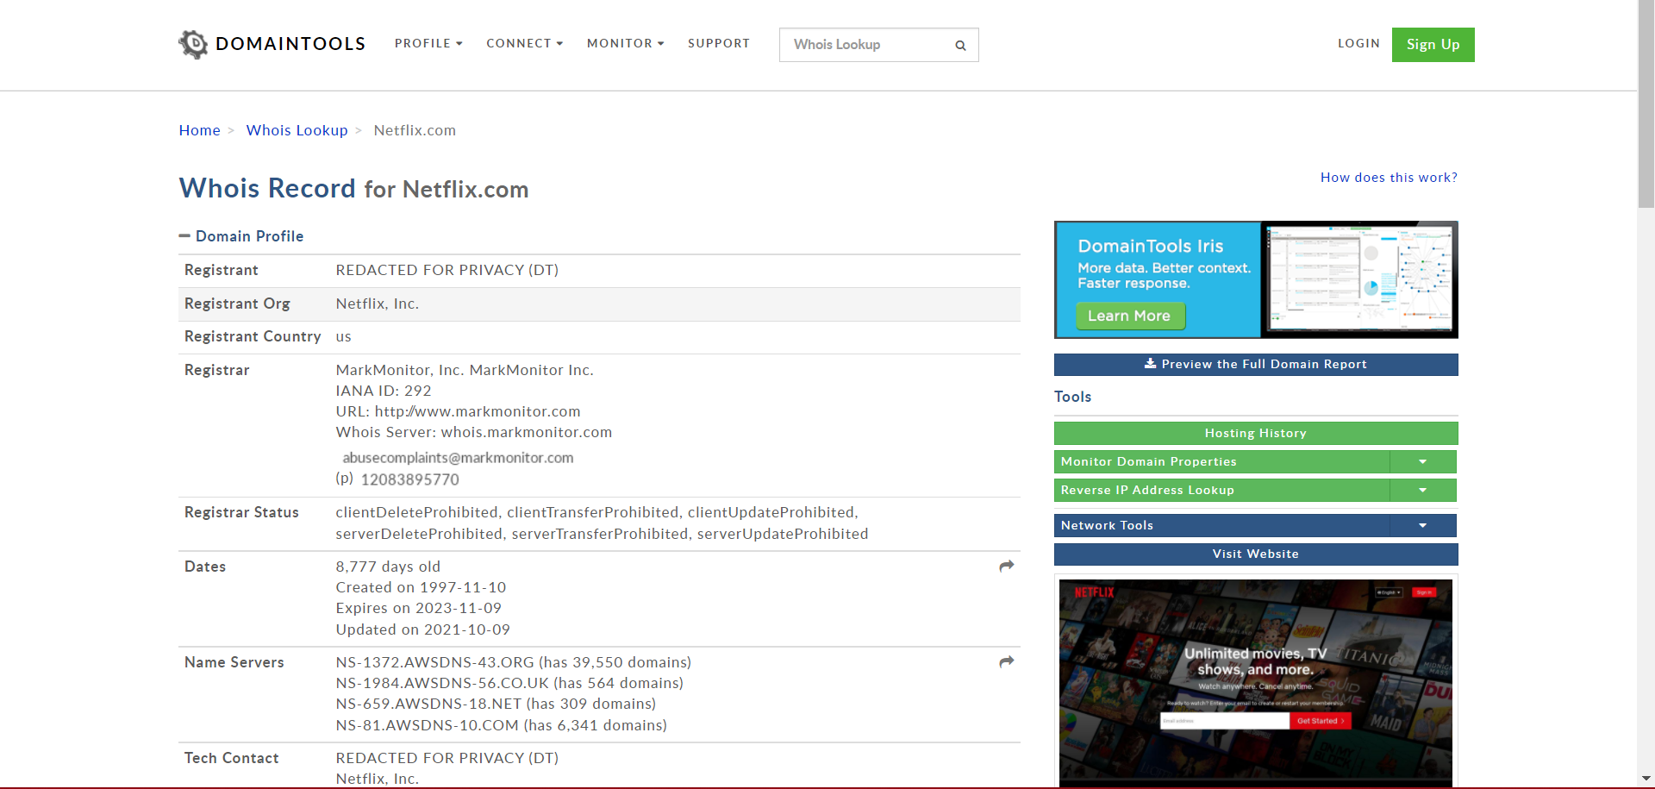

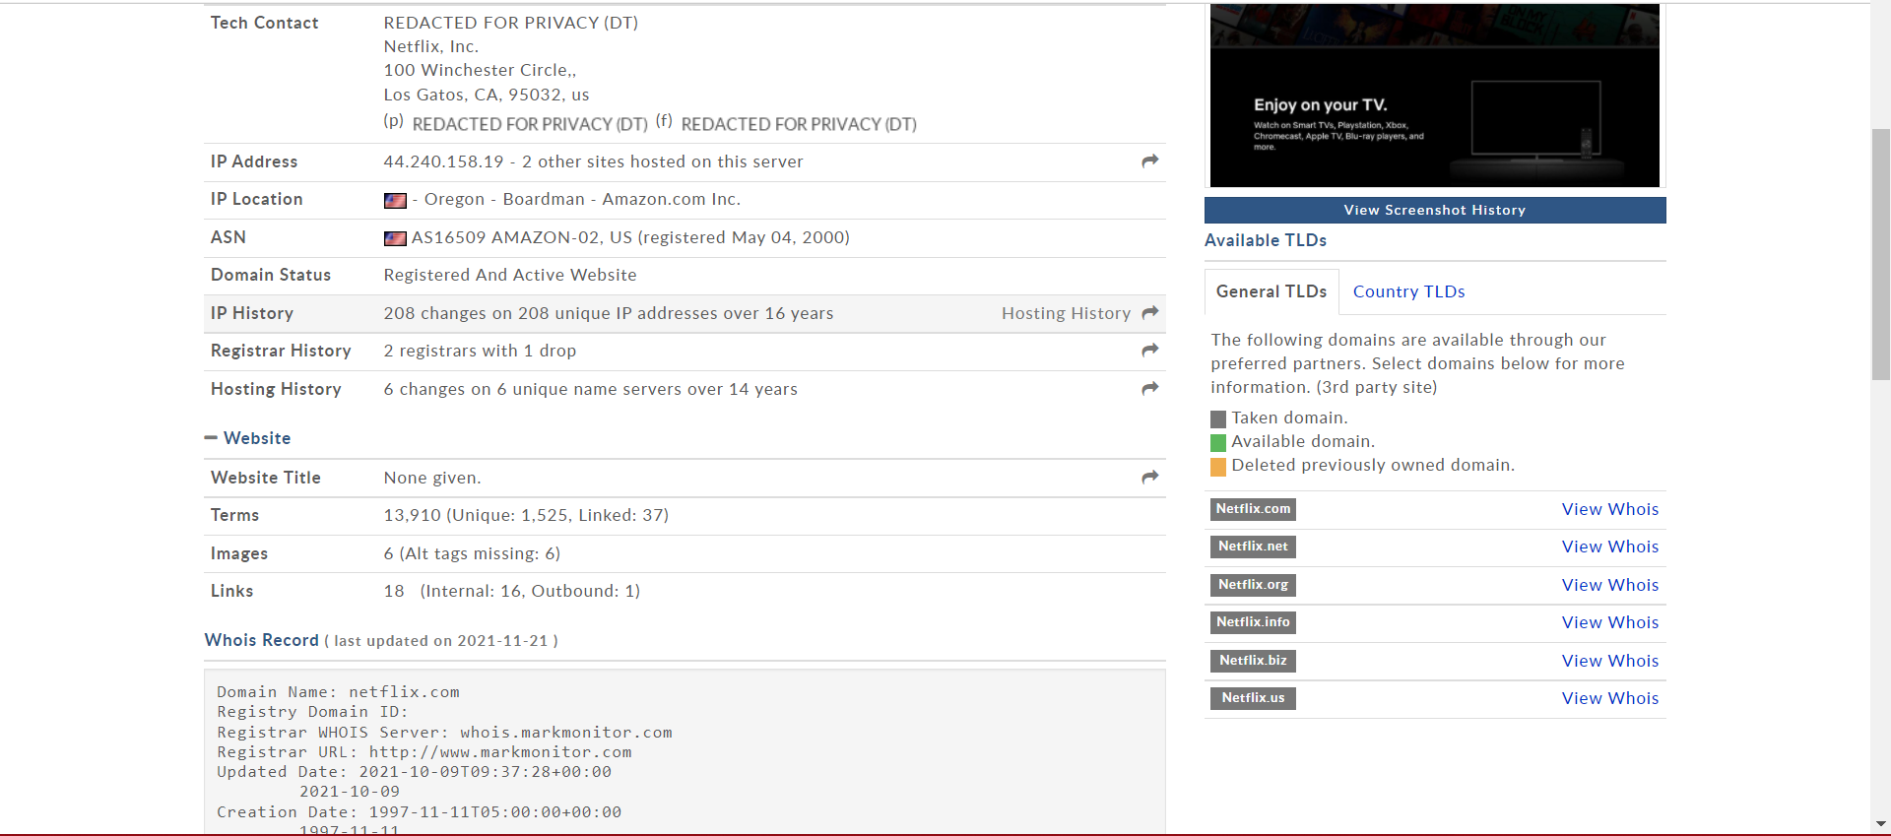

Whois Record of Netflix.com:

Domain Name: netflix.com  
Registry Domain ID:   
Registrar WHOIS Server: whois.markmonitor.com  
Registrar URL: http://www.markmonitor.com  
Updated Date: 2021-10-09T09:37:28+00:00  
        2021-10-09  
Creation Date: 1997-11-11T05:00:00+00:00  
        1997-11-11  
Registrar Registration Expiration Date: 2023-11-10T00:00:00+00:00  
        2023-11-10  
Registrar: MarkMonitor, Inc.  
        MarkMonitor Inc.  
Sponsoring Registrar IANA ID: 292  
Registrar Abuse Contact Email: [](https://reversewhois.domaintools.com/?email=86f127e68052cf1961e02764e9684f46)  
Registrar Abuse Contact Phone: 12083895770  
Status:   
        clientDeleteProhibited  
        clientTransferProhibited  
        clientUpdateProhibited  
        serverDeleteProhibited  
        serverTransferProhibited  
        serverUpdateProhibited  
Registry Registrant ID:   
Registrant Name: REDACTED FOR PRIVACY (DT)  
Registrant Organization: Netflix, Inc.  
Registrant Street: 100 Winchester Circle,  
Registrant City: Los Gatos  
Registrant State/Province: CA  
Registrant Postal Code: 95032  
Registrant Country: us  
Registrant Phone: 14085403700  
Registrant Phone Ext:   
Registrant Fax: 14085403737  
Registrant Fax Ext:   
Registrant Email: REDACTED FOR PRIVACY (DT)  
Registry Admin ID:   
Admin Name: REDACTED FOR PRIVACY (DT)  
Admin Organization: Netflix, Inc.  
Admin Street: 100 Winchester Circle,  
Admin City: Los Gatos  
Admin State/Province: CA  
Admin Postal Code: 95032  
Admin Country: us  
Admin Phone: REDACTED FOR PRIVACY (DT)  
Admin Phone Ext:   
Admin Fax: REDACTED FOR PRIVACY (DT)  
Admin Fax Ext:   
Admin Email: REDACTED FOR PRIVACY (DT)  
Registry Tech ID:   
Tech Name: REDACTED FOR PRIVACY (DT)  
Tech Organization: Netflix, Inc.  
Tech Street: 100 Winchester Circle,  
Tech City: Los Gatos  
Tech State/Province: CA  
Tech Postal Code: 95032  
Tech Country: us  
Tech Phone: REDACTED FOR PRIVACY (DT)  
Tech Phone Ext:   
Tech Fax: REDACTED FOR PRIVACY (DT)  
Tech Fax Ext:   
Tech Email: REDACTED FOR PRIVACY (DT)  
Registry Billing ID:   
Billing Name:   
Billing Organization:   
Billing Street:   
Billing City:   
Billing State/Province:   
Billing Postal Code:   
Billing Country:   
Billing Phone:   
Billing Phone Ext:   
Billing Fax:   
Billing Fax Ext:   
Billing Email:   
Nameservers:   
        ns-1372.awsdns-43.org  
        ns-1984.awsdns-56.co.uk  
        ns-659.awsdns-18.net  
        ns-81.awsdns-10.com  
Registry ID: 1404215_DOMAIN_COM-VRSN  
DNSSEC: unsigned

**WEB TOOL: NETCRAFT**

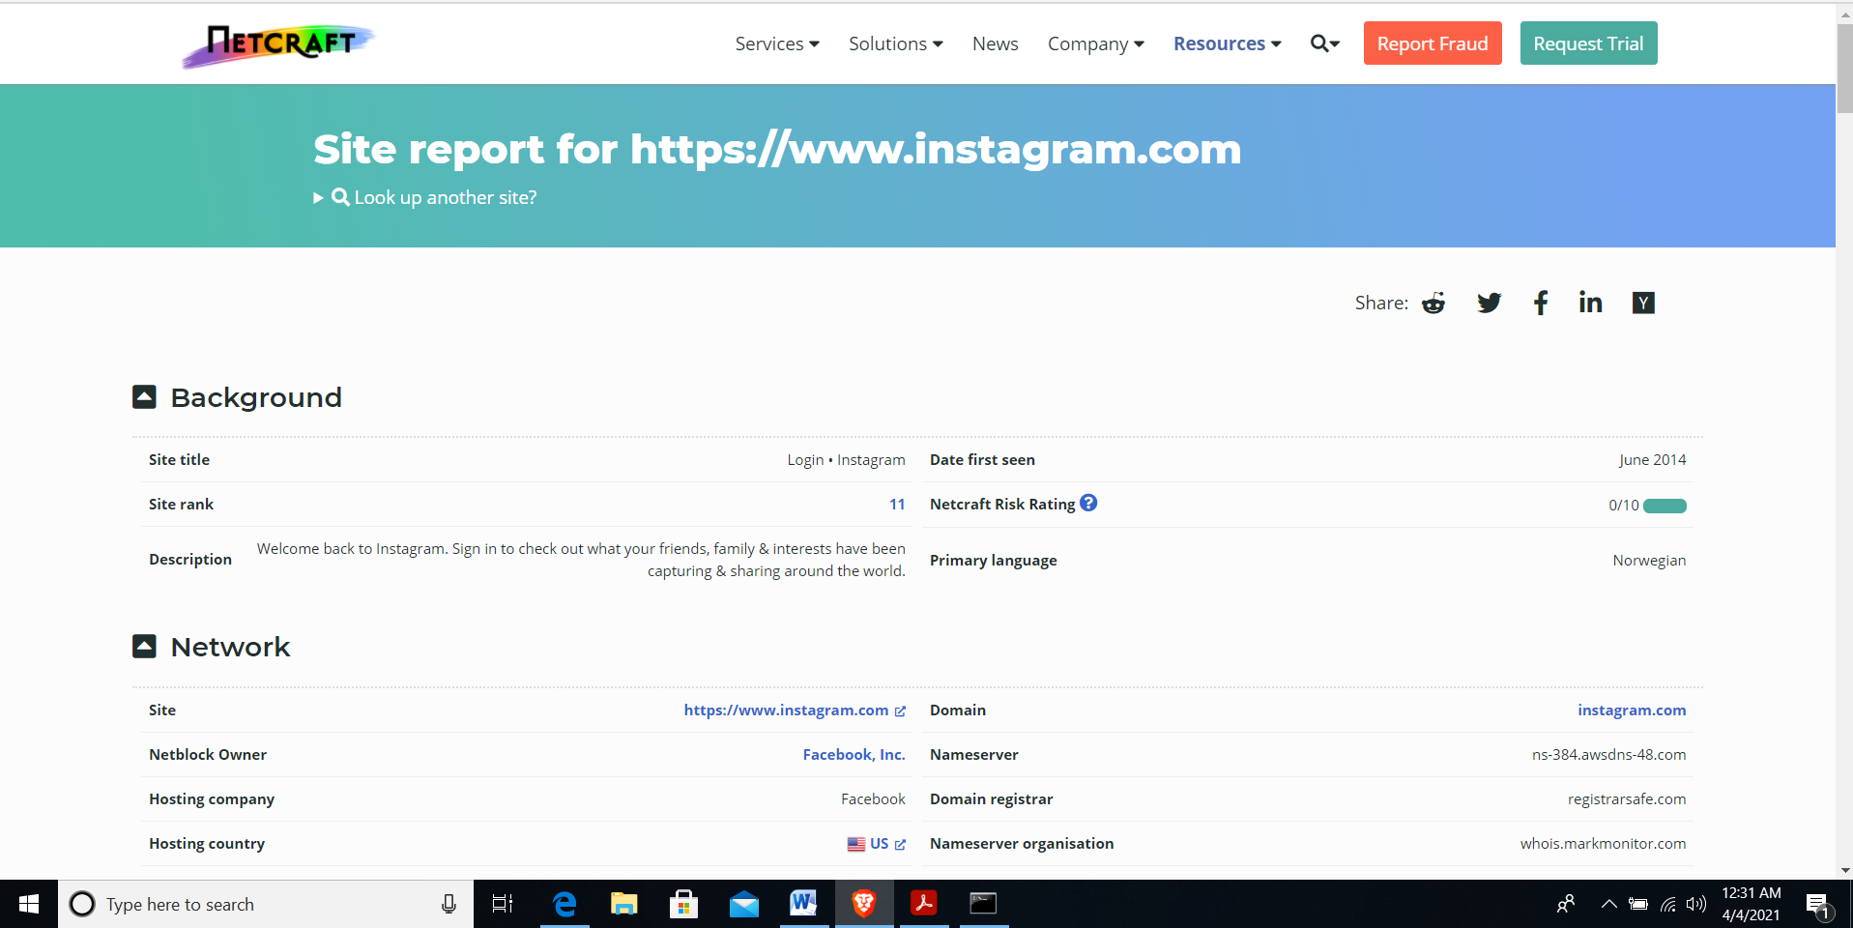

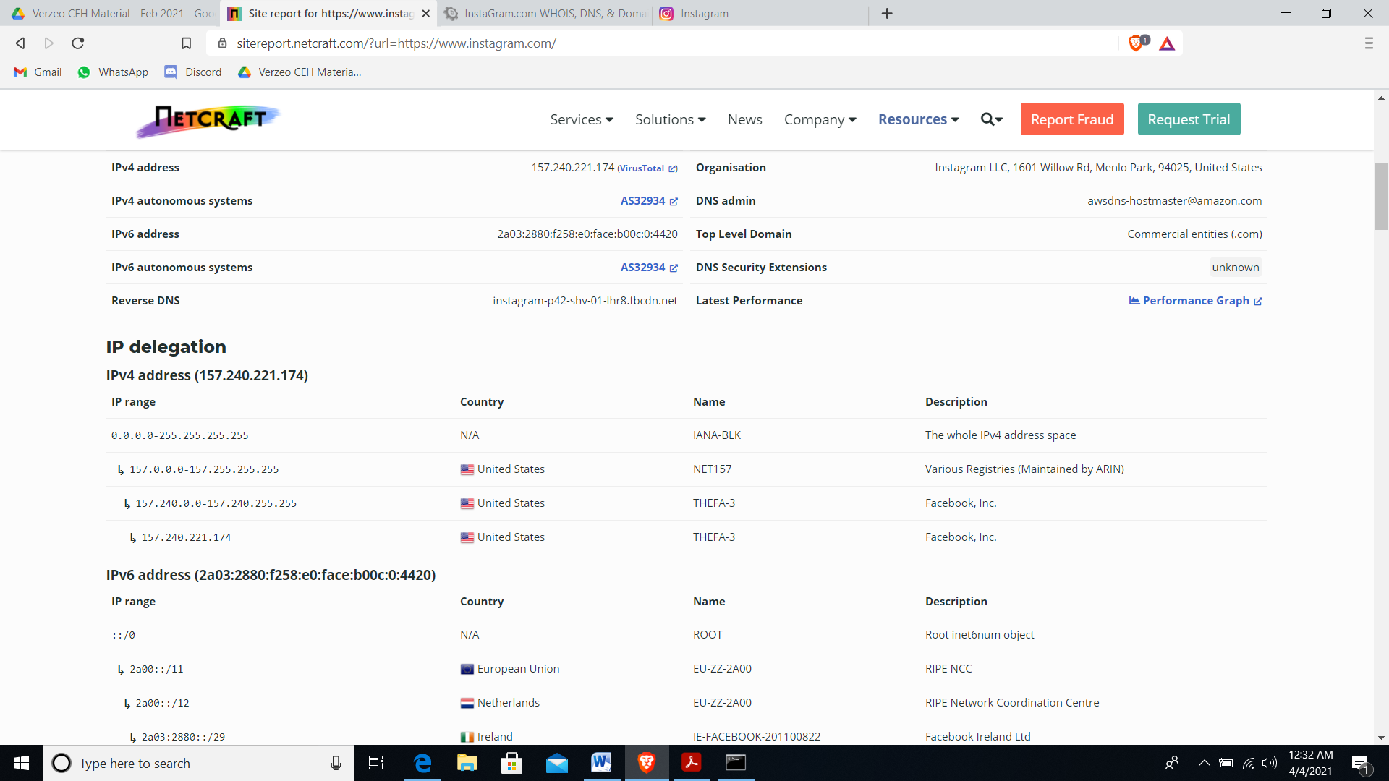

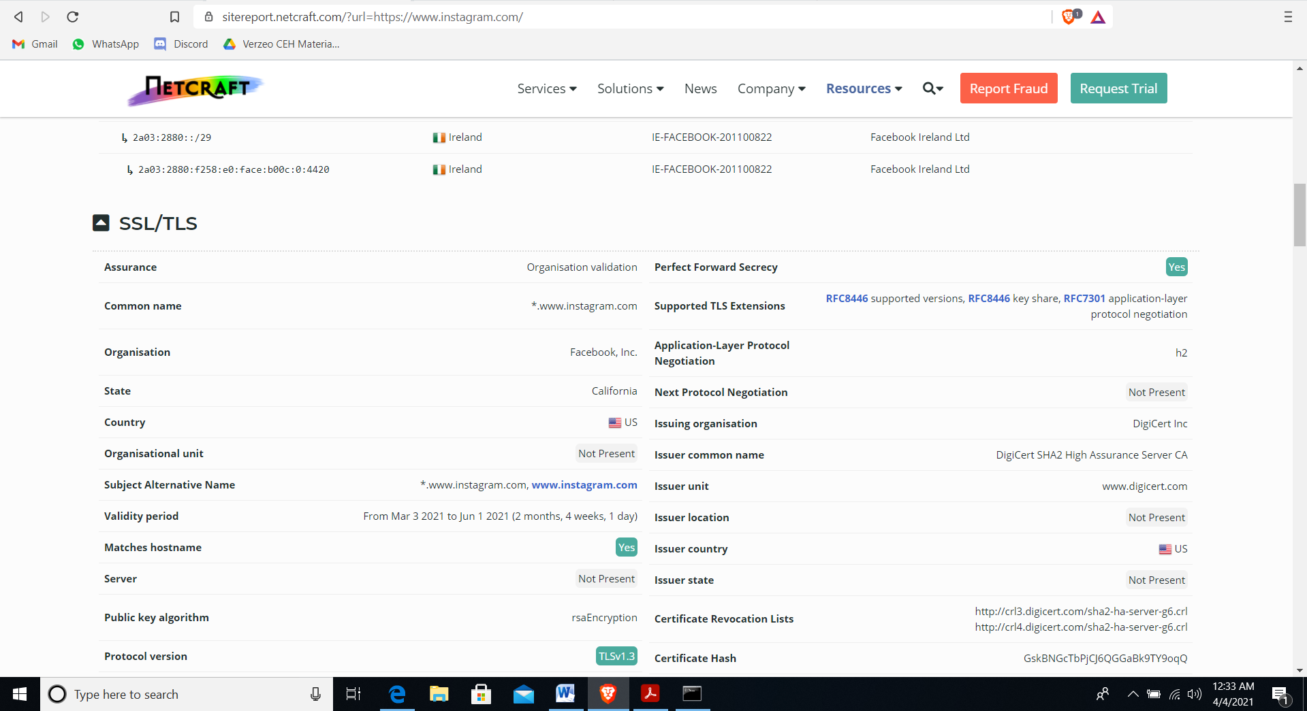

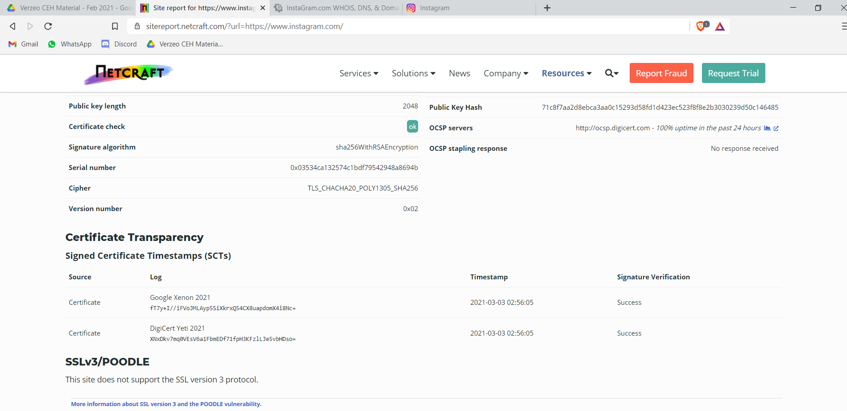

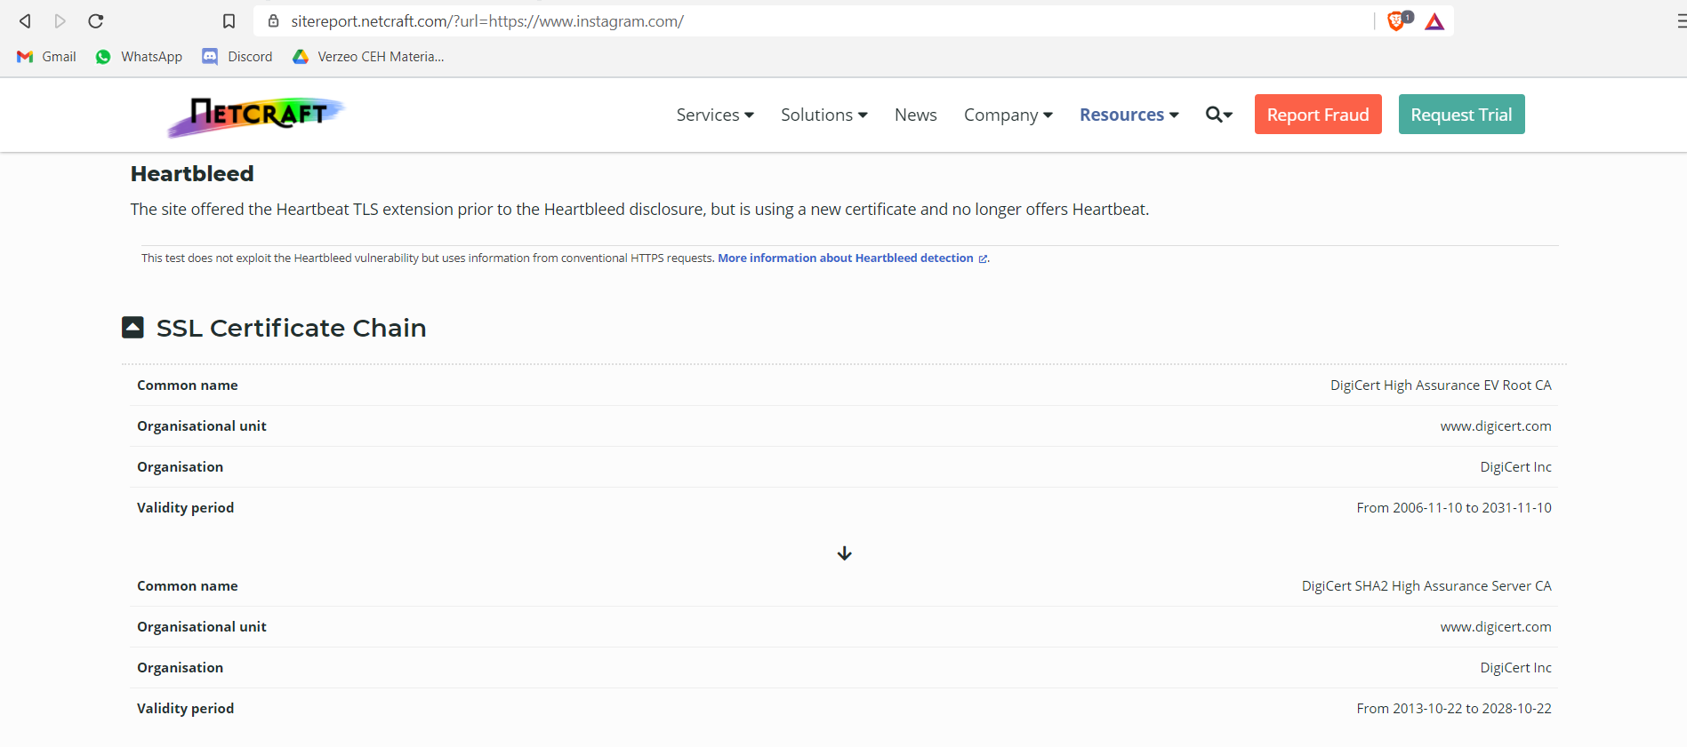

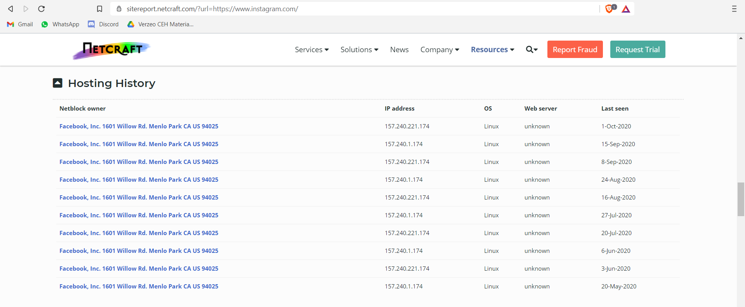

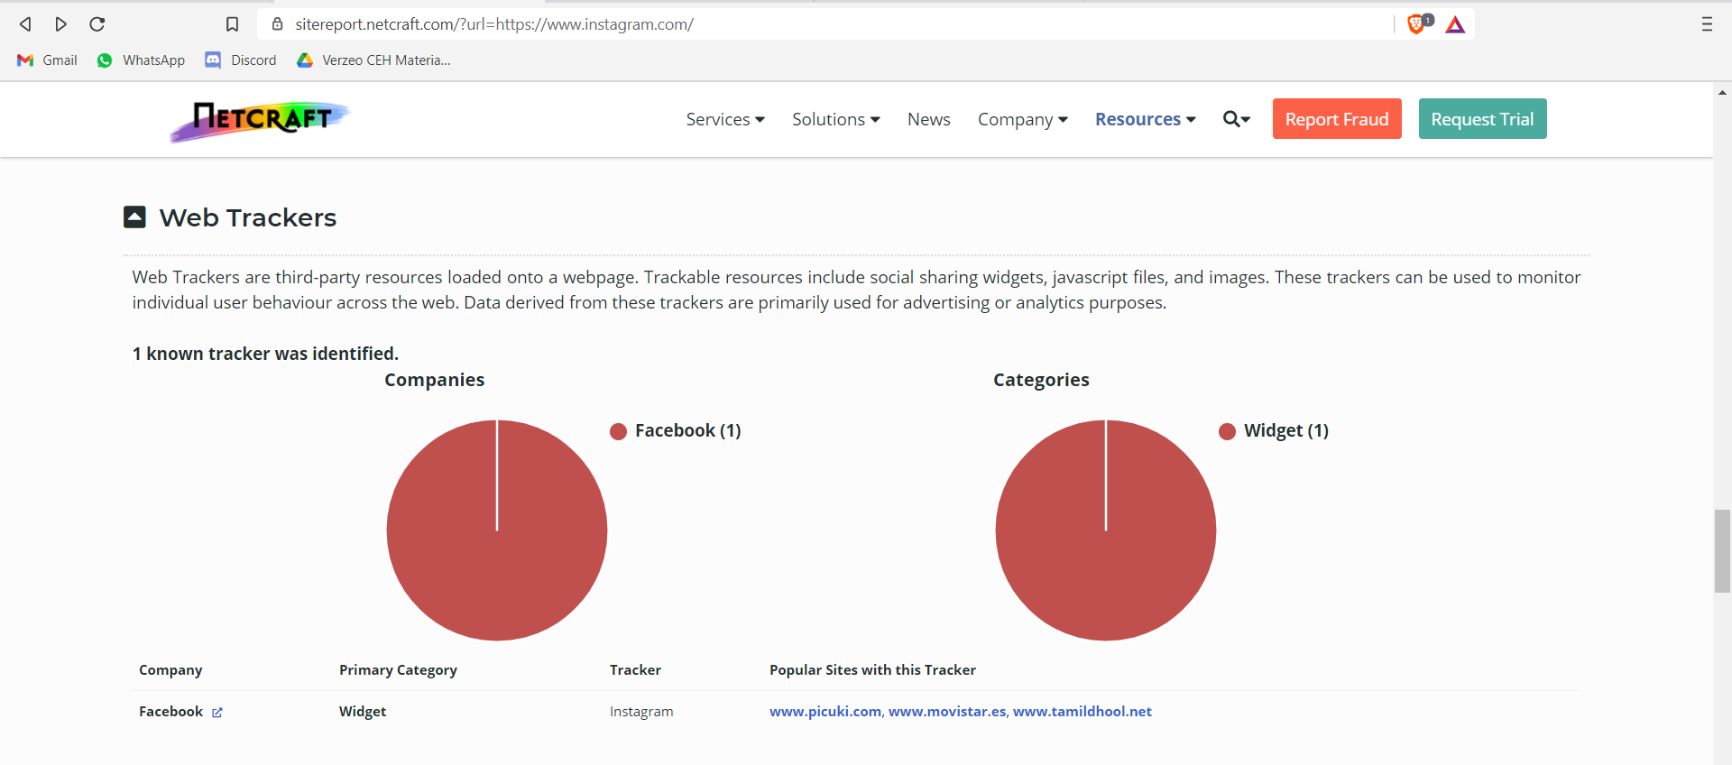

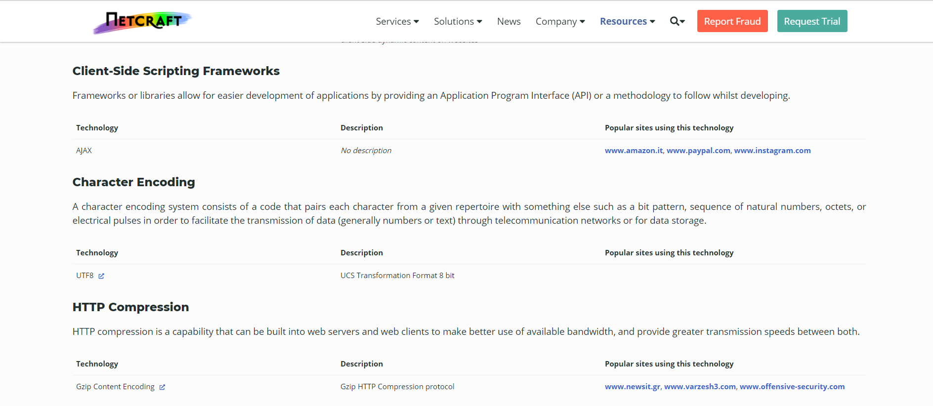

**WEB TOOL: DOMAIN DOSSIER**

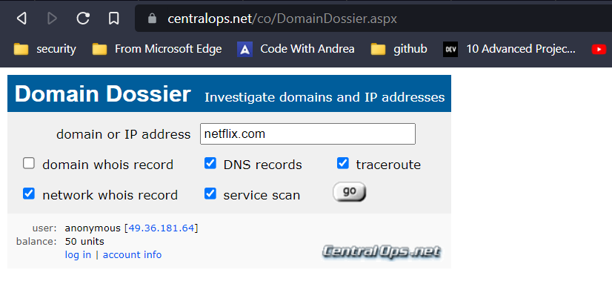

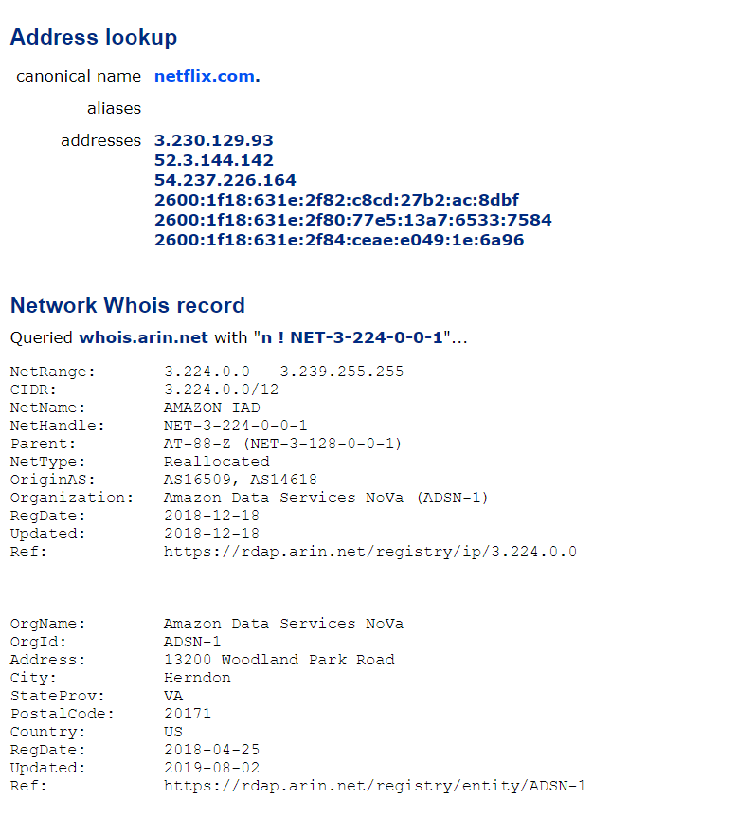

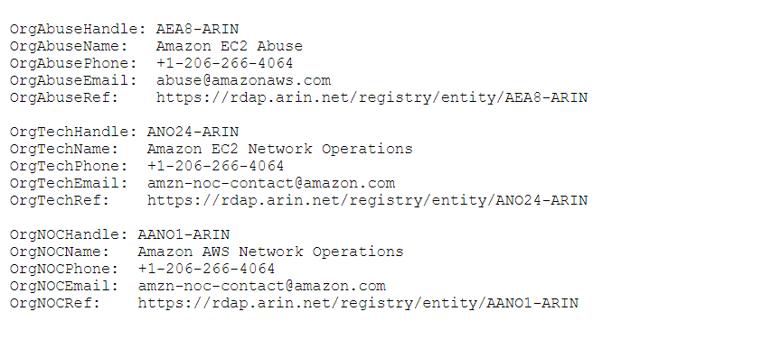

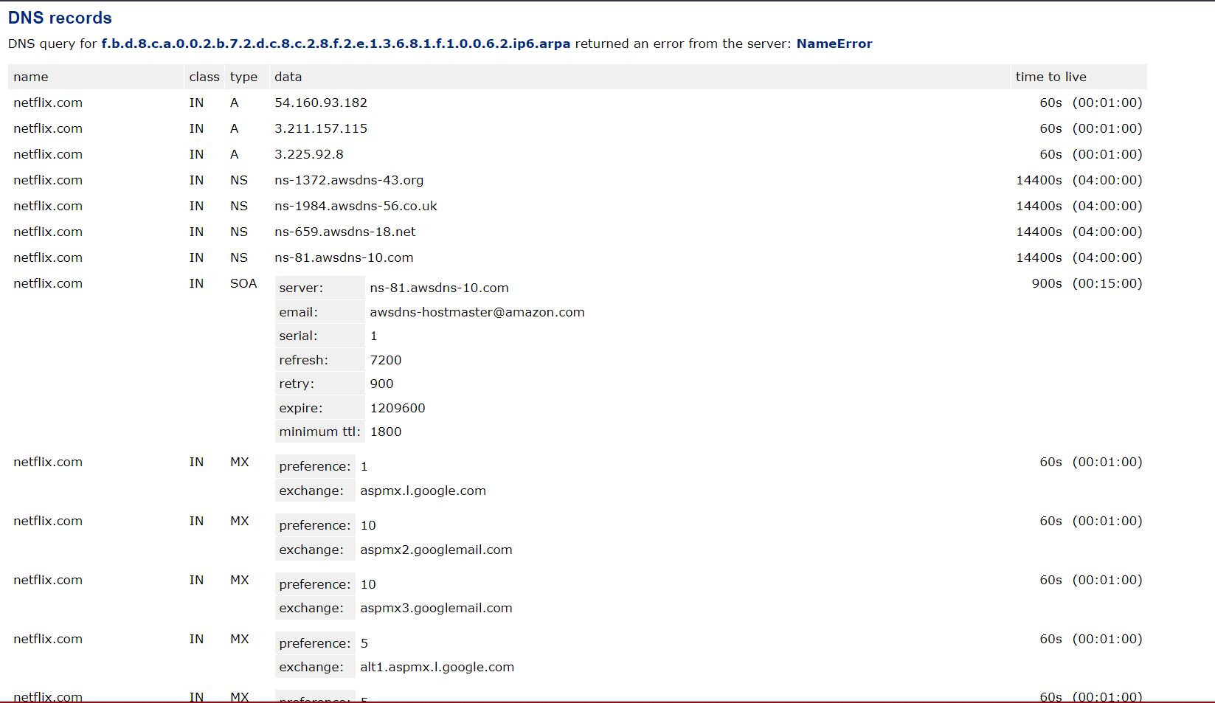

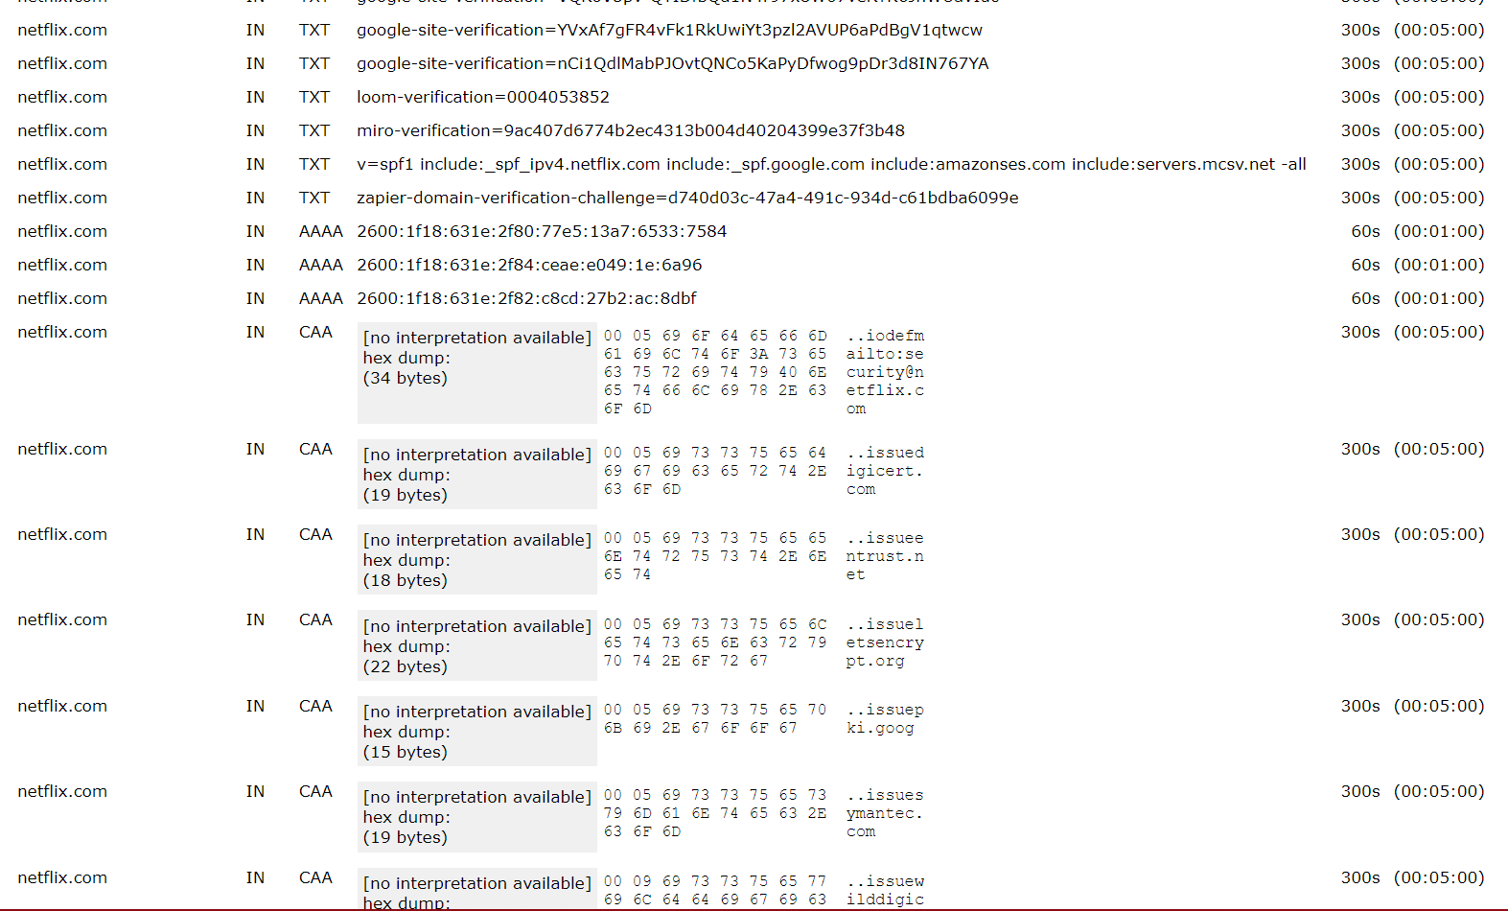

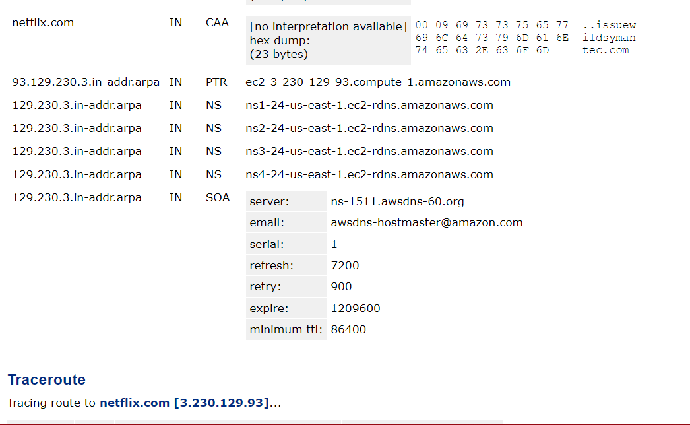

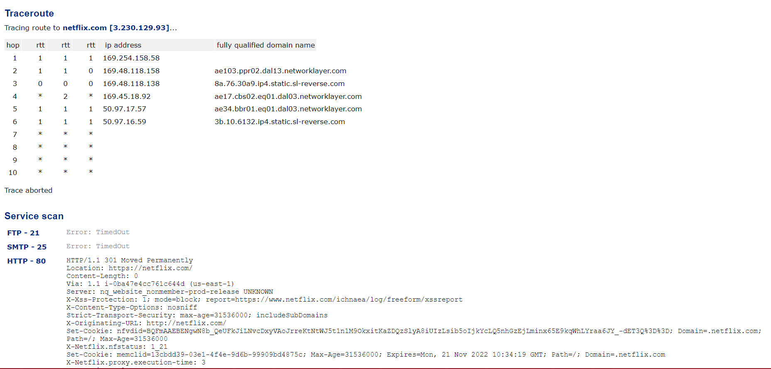

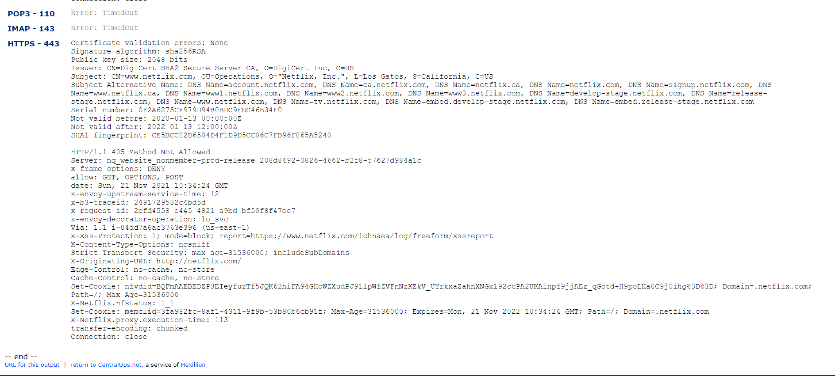

**DNS RECON**:

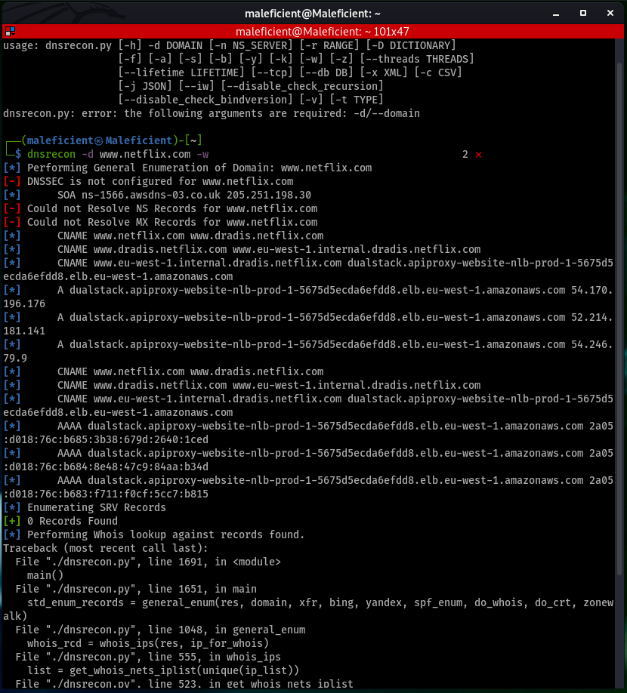

**DNS ENUM**:

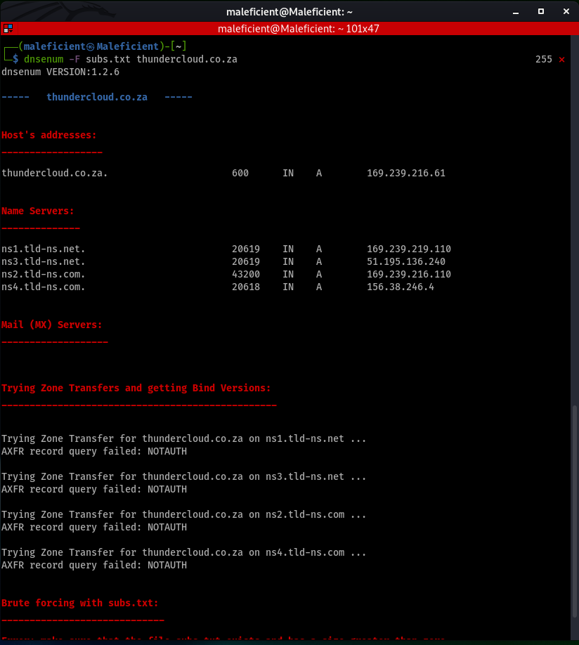

**WEB TOOL: DNS DUMPSTER**

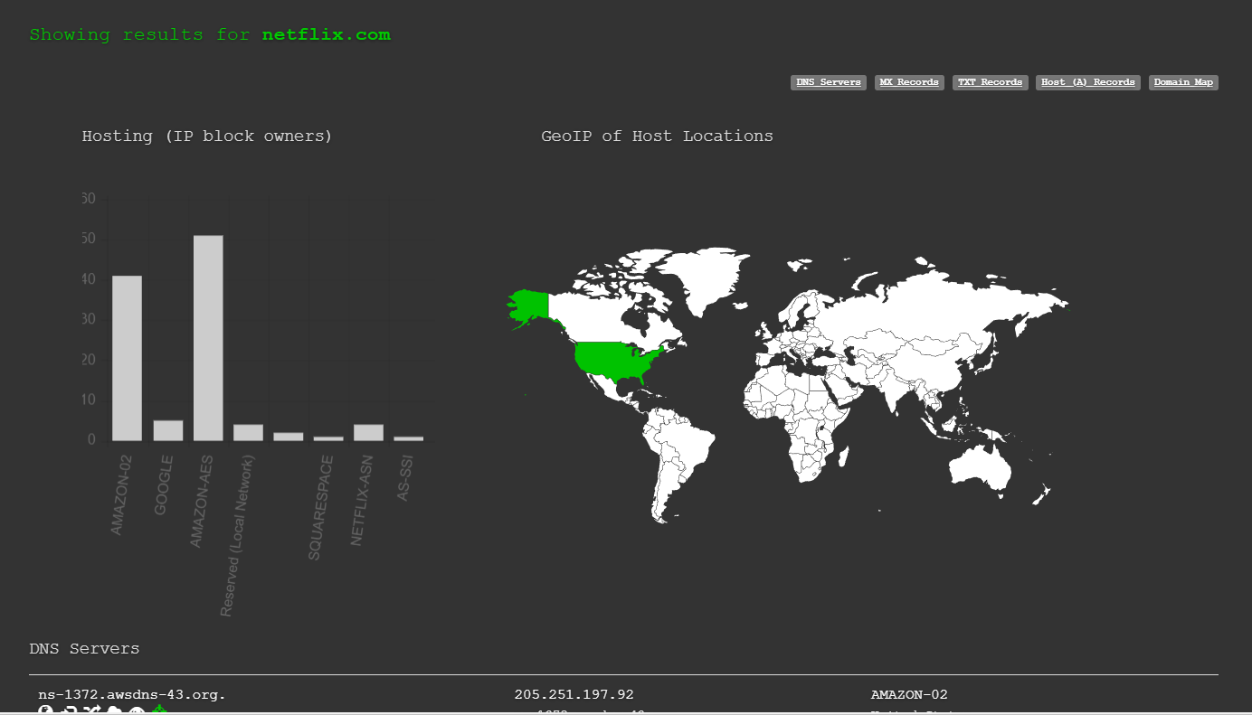

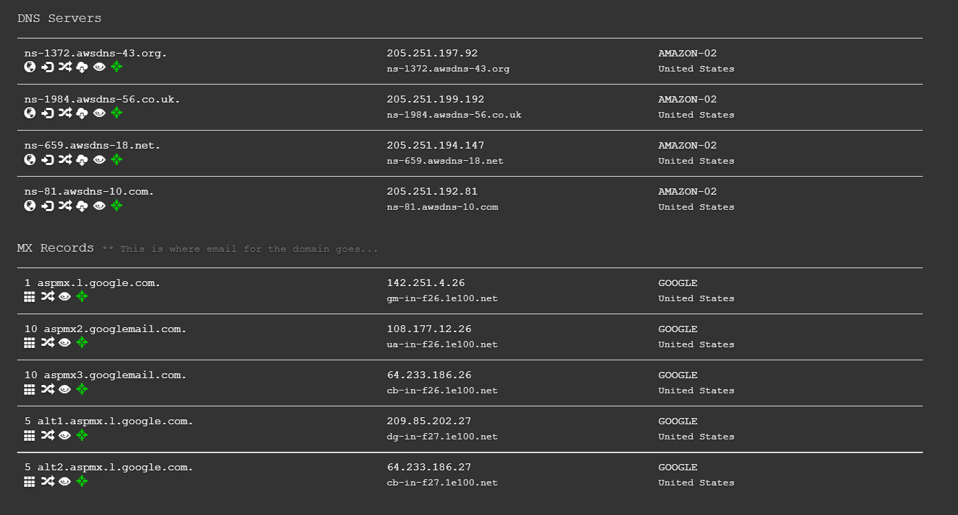

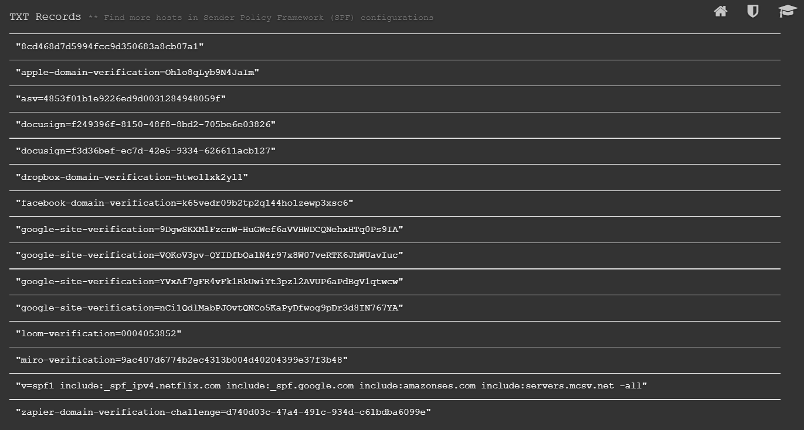

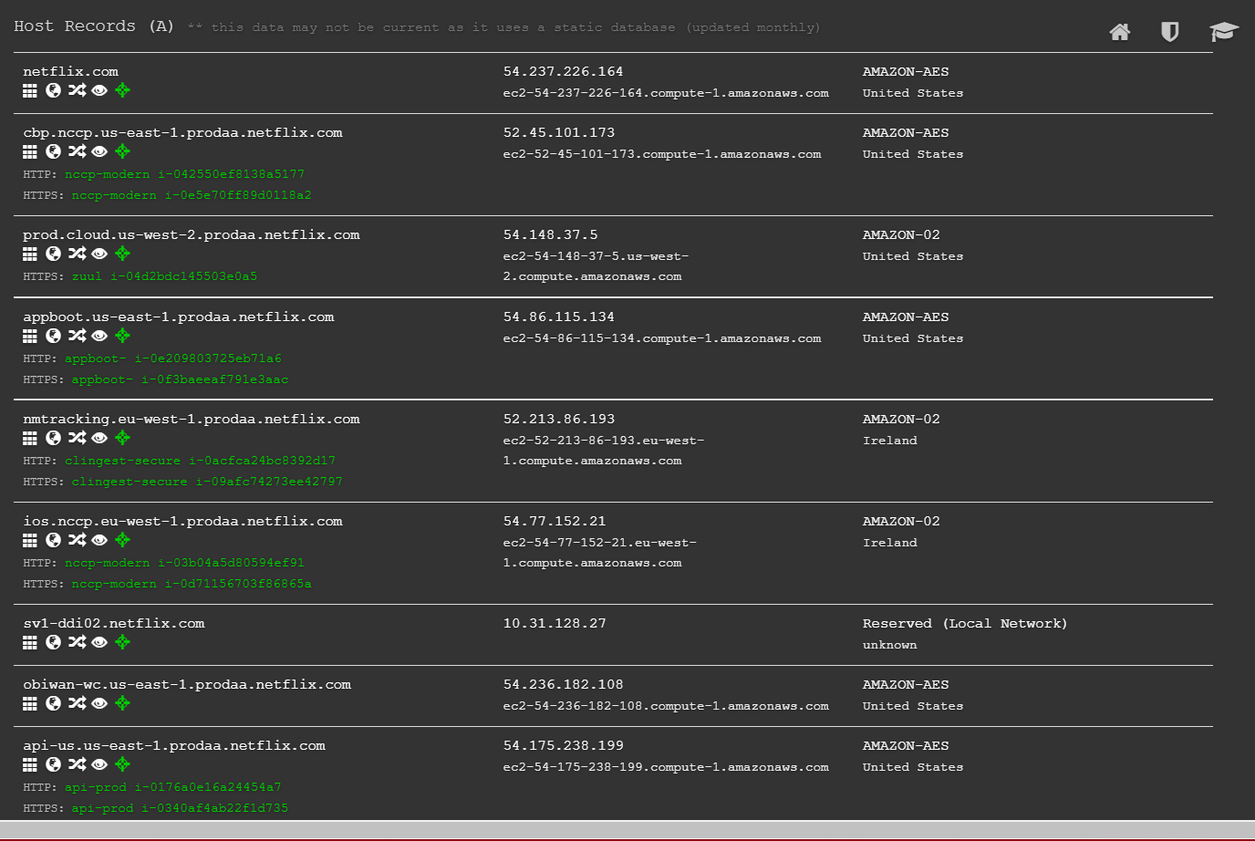

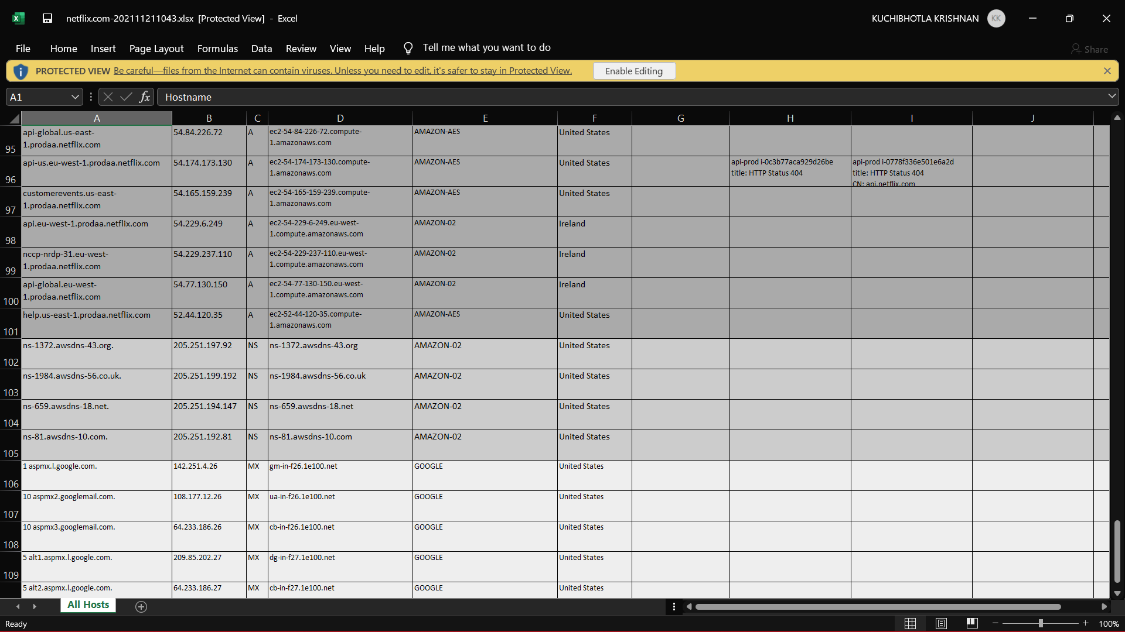

**EXPERIMENT NO – 9**

**AIM:** Implementation of File System Security.

**THEORY**:

VeraCrypt is an Free and Open Source utility used for on-the-fly encryption. It can create a virtual encrypted disk within a file or encrypt a partition or the entire storage device with pre-boot authentication. Individual ciphers supported by VeraCrypt are AES, Serpent, Twofish, Camellia, and Kuznyechik.

Additionally, ten different combinations of cascaded algorithms are available: AES–Twofish, AES–Twofish–Serpent, Camellia–Kuznyechik, Camellia–Serpent, Kuznyechik–AES, Kuznyechik–Serpent–Camellia, Kuznyechik–Twofish, Serpent–AES, Serpent–Twofish–AES, and Twofish–Serpent.

The cryptographic hash functions available for use in VeraCrypt are RIPEMD-160, SHA-256, SHA-512, Streebog and Whirlpool.

**STEPS OF PERFORMING FILE SECURITY**:

1. Open VeraCrypt tool and Click on the Create Volume.
2. Create a Standard Veracrypt volume.
3. From the select file menu, point to destination of created volume.
4. Choose the Encryption Option.
5. Create a password for said volume, be sure to use a complex password and never forget this password you set.
6. Move your mouse as randomly as possible, as tool will calculate hash based on mouse movement here, thus more random, more secure it will be once collection is complete click on the format and wait for the formatting of volume to finish.
7. Click on mount button and locate your newly create volume, once mounted it’ll show itself on the main screen.
8. Now the volume has been mounted, you can transfer your folder containing sensitive info into it like a normal drive, and once you unmount, the information in the volume created will no longer will be accessible to anyone.

**OUTPUT**:

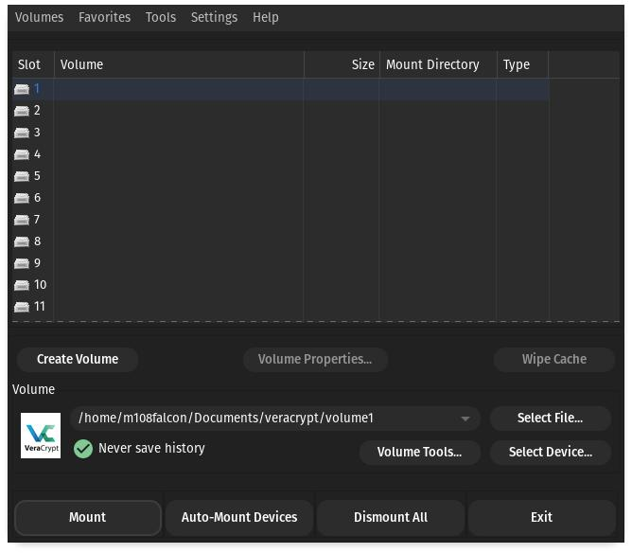

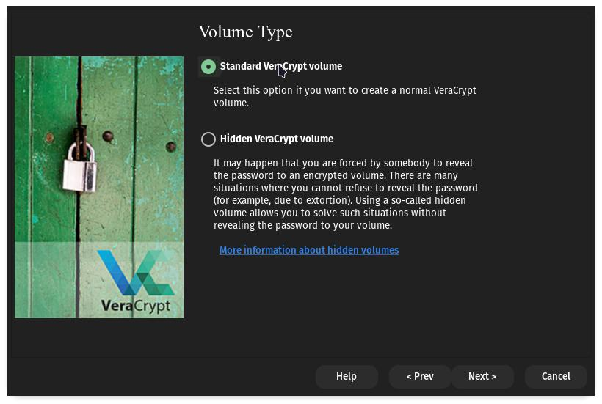

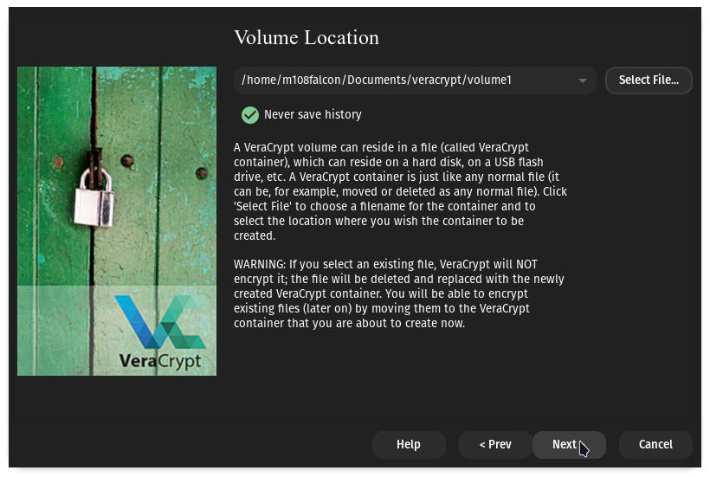

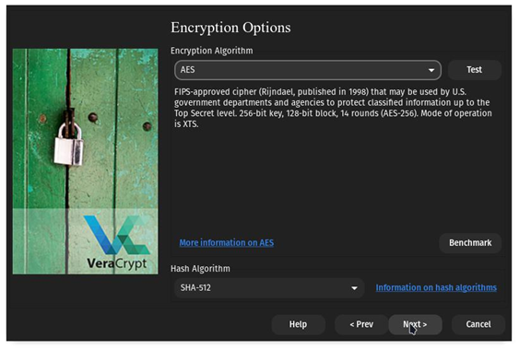

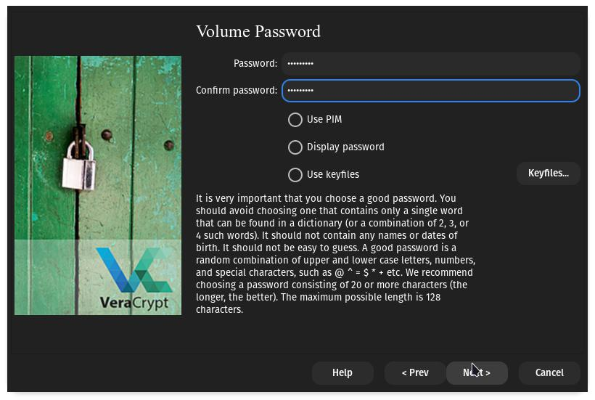

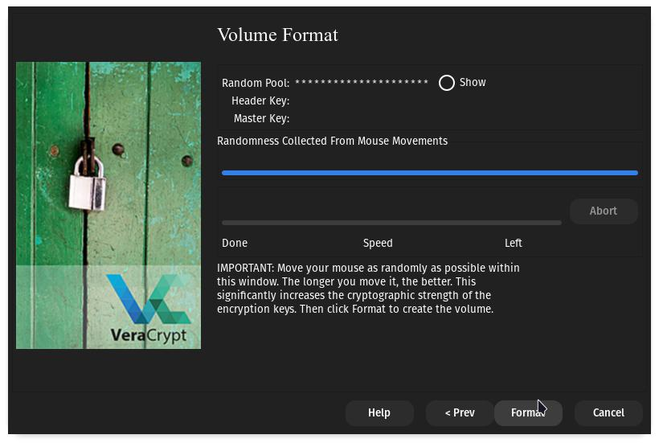

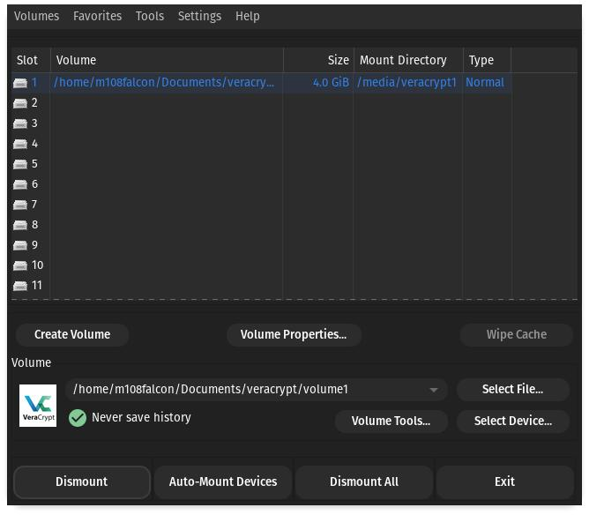

**EXPERIMENT NO – 10**

**AIM**: Implementation of Cryptography Lab.

**THEORY**:

Symmetric key cryptography is any cryptographic algorithm that is based on a shared key that is used to encrypt or decrypt text/cyphertext, in contract to asymmetric key cryptography, where the encryption and decryption keys are different. The keys may be identical, or there may be a simple transformation to go between the two keys. Symmetric-key encryption can use either stream ciphers or block ciphers.

1.Stream Cipher encrypt the digits (typically bytes), or letters (in substitution ciphers) of a message one at a time.

2.Block Cipher take a number of bits and encrypt them as a single unit, padding the plaintext so that it is a multiple of the block size.

Implementation of DES: Disk Encryption System

**Encryption:**

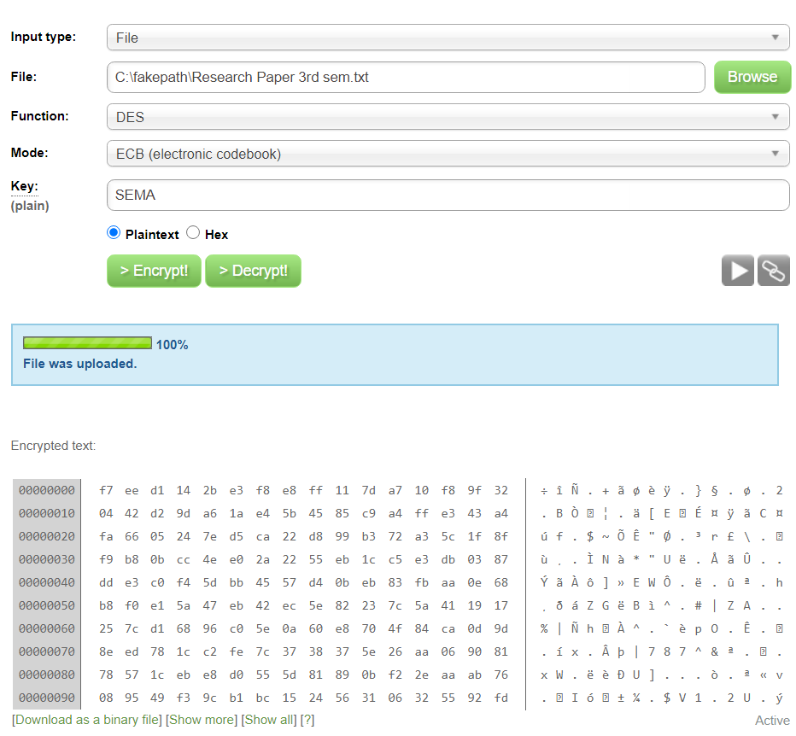

**Decryption:**

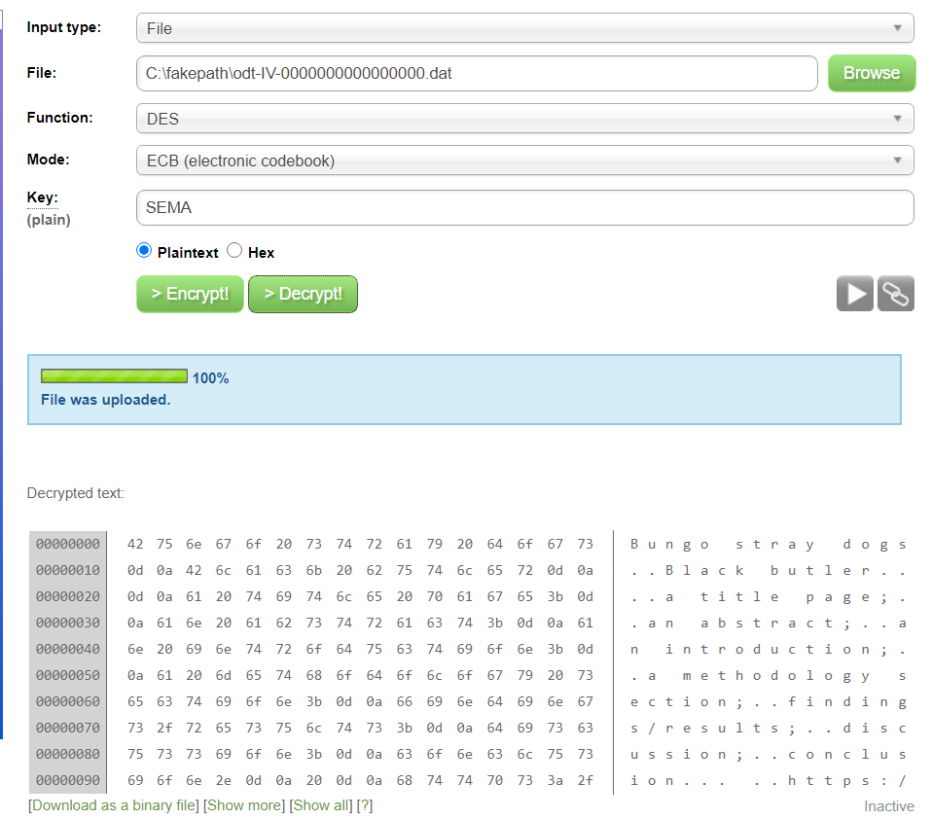

Asymmetric cryptography is a branch of cryptography where a secret key can be divided into two parts, a public key and a private key. The public key can be given to anyone, trusted or not, while the private key must be kept secret (just like the key in symmetric cryptography).

Asymmetric cryptography has two primary use cases: authentication and confidentiality. Using asymmetric cryptography, messages can be signed with a private key, and then anyone with the public key is able to verify that the message was created by someone possessing the corresponding private key.

Implementation of AES: Advanced Encryption Standard

Encryption and Decryption:

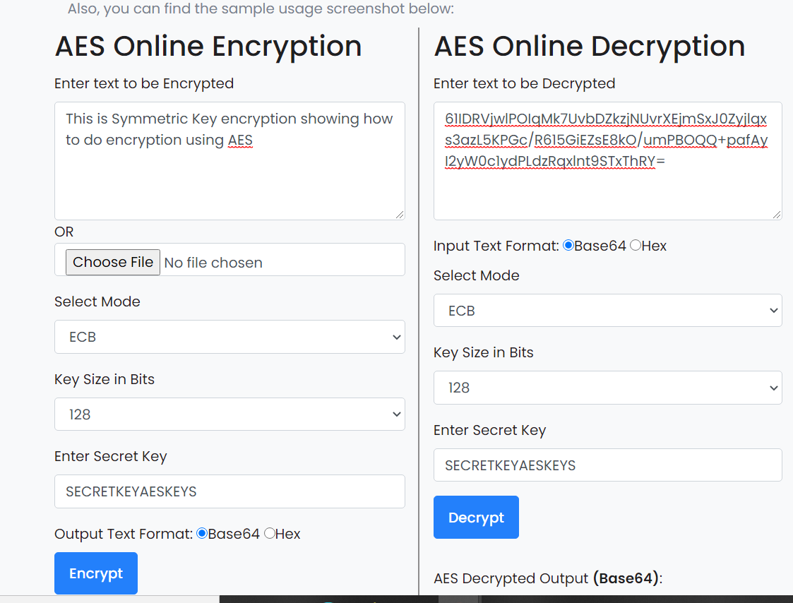

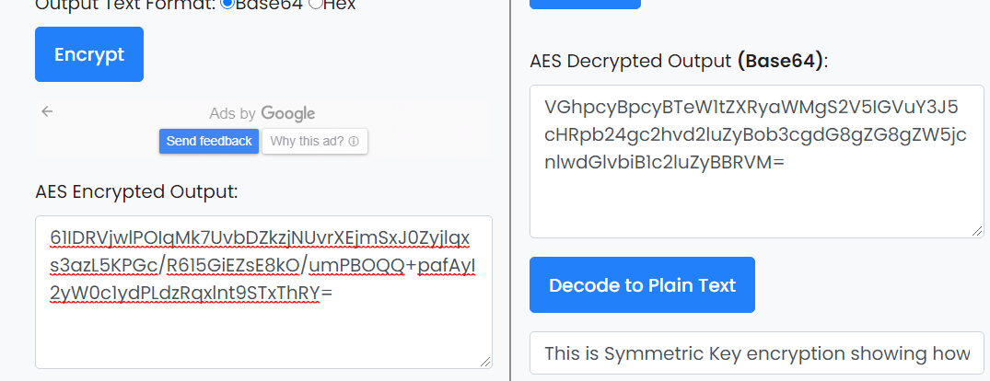

**EXPERIMENT NO – 11**

**AIM**: Implementation of Network Security Tools and Technologies Lab.

Windows firewall :

Windows Firewall is a stateful firewall that inspects and filters all packets for IP version 4 (IPv4) and IP version 6 (IPv6) traffic. For measuring the performance of windows firewall, first rules are created for inbound and outbound connections and then performance is measured by enablining and diseabling the firewall rule. Rule creation In firewall, firewall rules are to created to allow this computer to send traffic to or receive traffic from. Firewall rules can be created to take one of two actions for all connections that match the rule's criteria: allow the connection or block the connection. Rules can be created for either inbound traffic or outbound traffic

The rule can be configured to specify the computers, programs, services, ports and protocols. As IT environment changes, user might have to change, create, disable or delete rules. Rule creations involve following steps.

Step 1. Select the rule category either inbound (for incoming connection) or outbound (for outgoing connection)

Step 2. In the second step select the rule type, which type of rule would you like to create? program, port, predefined and custom

Step 3. Select any one rule. For eg. Rule for port has selected, now specified the port number (80,25,20,21) and the protocol (TCP,UDP).

Step 4. Select the action which can be performed if rule matched whether block the connection or allow the connection.

Windows firewall creation: 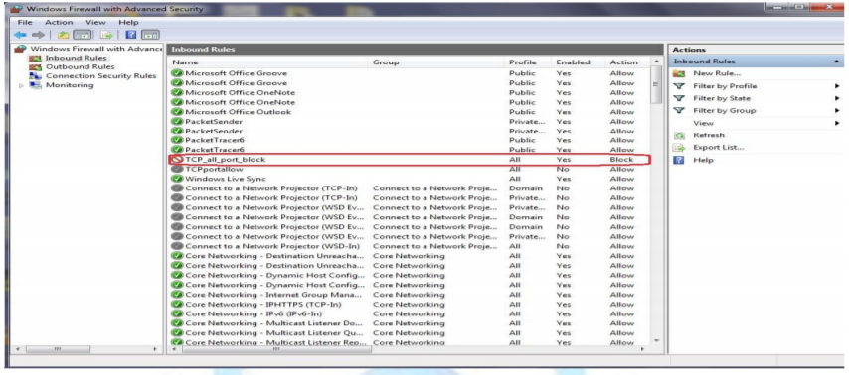

Linux firewall:

Iptables is an application program that permits a system administrator to configure or manage the iptables provided by the Linux kernel firewall. It is used to setup, maintain and inspect the tables of IP chains. It is a consol based firewall service program that uses policy chains to accept or reject the network traffic. When any connection is tried to establish from any network to private network either inbound or outbound, iptables check for a rule in its stored rule base. If there is a match found then corresponding action take place, otherwise default action is applied. Iptables uses three different chains: input, forward and output.

• Input – This chain is used to control the all incoming connections from the public network. For example, if a user attempts to TELNET or SSH into your PC/server, iptables will attempt to match the IP address and port to a rule in the input chain.

• Forward – This chain is used for incoming connections that are not actually being delivered locally same as router that forwards the packets to its outgoing links

. • Output – This chain is used to control all the outgoing connections from private network to public network. If user tries to access facebook.com, iptables will check its output chain to see what the rules are stored regarding to http before making a decision to allow or deny the connection. There are three types of connection-specific Responses in Iptables

• Accept – Allow the connection.

• Drop – Drop the connection, act like it never happened. This is best when user does not want the source to realize his/her system exists.

• Reject – Do not allow the connection, but send back an error to the originator. This is best if user does not want a particular source to connect to his/her system, but user wants them to know that his/her firewall blocked them.

For measuring the performance of Linux firewall, first rules are created for inbound and outbound connections and then performance is measured by enablining and diseabling the firewall.

Rule creation Gufw is a graphical uncomplicated firewall that provides user-friendly frontend to IPTables. It is used to manage the rules and policies of IPTables in easier way.Gufw allows the administarator to create preconfigured, simple and advanced rules

Creating rule to reject FTP: 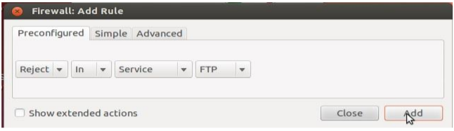

Shows a firewall rule that will allow tcp port 25 to any address on this host.

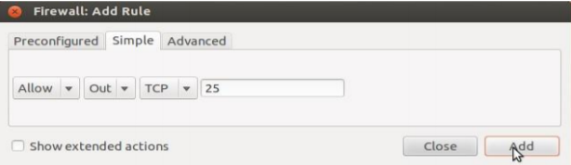

Shows ufw status that contains all the created rules.

